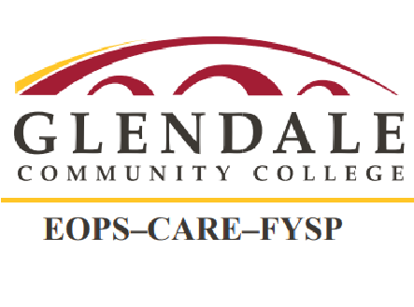
Extended Opportunity Programs and Services (EOPS)
Cooperative Agencies and Resources for Education (CARE)
Foster Youth Support Program (FYSP)
Hybrid Services
Office: Sierra Vista Building, 3rd Floor
Email: eopsdesk@glendale.edu
Phone & Voicemail: 818-240-1000 ext. 6900
NOTE: Please read the entire message carefully.
———————————————————————————————————————————————————————————
Dear EOPS student,

Beginning February 9, 2026 your book voucher information will be available ONLINE through your student portal-MyGCC.

If you are eligible, you will get $350.00 for Spring 2026. You will he able to complete your book purchase online or in-person with the Glendale College bookstore. If you are new to using the EOPS book voucher for online purchases please refer to the Q&A document below to learn how to purchase your books with the EOPS Book Voucher.

Click here to open a link to the Q&A document to help you properly access and use your EOPS book voucher ONLINE.

If you are not eligible for winter 2026 book voucher, you will see $0.00 listed for the award amount in your student portal. There, click on that $0.00 to find out the reason for your ineligibility.

Spring 2026
FIRST DAY YOU CAN USE YOUR BOOK VOUCHER IS MONDAY, FEBRUARY 9, 2026.
LAST DAY YOU CAN USE YOUR BOOK VOUCHER IS MONDAY, APRIL 27, 2026.

You may use your EOPS book voucher to purchase your textbooks from the college bookstore ONLINE and get your books shipped to your home for $7.50, or pick up from the GCC bookstore free of charge. Check the Q&As below for pick up information. Don’t delay. Get your books early before it gets very busy in the bookstore.

You may also watch a video tutorial here on how to make your online book purchases from GCC bookstore using your EOPS book voucher.

EOPS book voucher may be used to purchase/rent only those books that are required for registered courses. EOPS book voucher shall not be used for supplies. EOPS book voucher is non-transferable. Under no circumstances, students may use their EOPS book voucher to purchase books for another individual.

NOTE: This message was distributed to all EOPS students. Please do not reply to this message. If you have any questions regarding your book voucher eligibility, please submit your inquiry online by completing the form available at the link provided. (Submit questions online).

