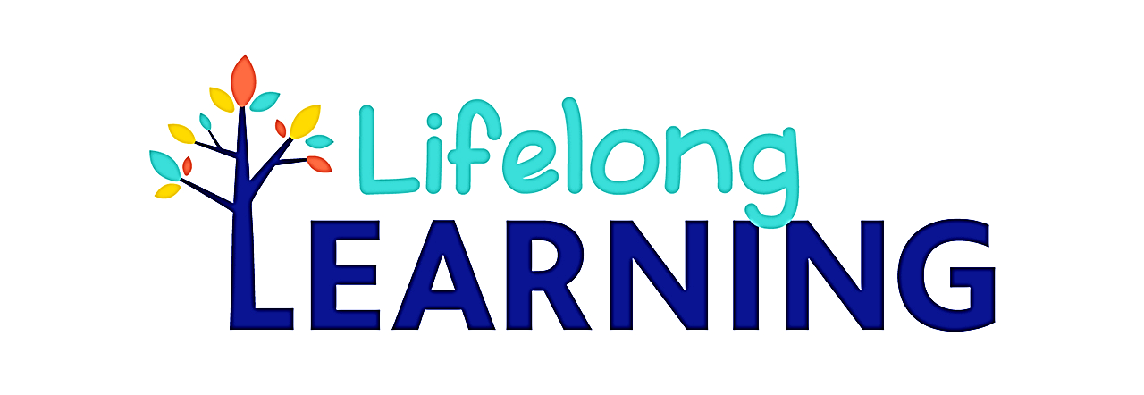Summer 2025
June 23 - July 26, 2025
Classes are Tuition Free

...An opportunity to participate in unique education programs designed for interested people of all ages

Film Appreciation
LLS 72 #1613 Garfield Campus Room MP 212 Thursday 1:00pm.-3:30pm. Sandra Ferguson
06/23-07/26/2025 1122 E. Garfield, Glendale, CA 91205

Glendale Community College Lifelong Learning Seminars offers classes designed for mature adults seeking
Educational opportunities. ALL CLASSES ARE FREE.
Register on line at www.glendale.edu for further information, please call (818) 240-1000 ext. 5690.

