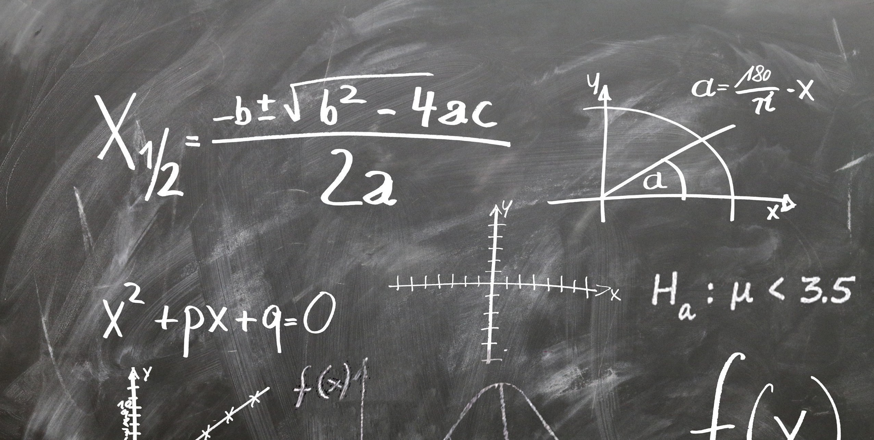
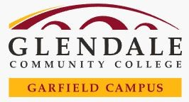
IMPROVE YOUR BASIC ALGEBRA OR STATISTICS SKILLS FOR FREE!

Has it been a while since you have taken Algebra or Statistics?
Do you wish to improve your math skills?

SIGN UP NOW!
BASIC STATISTICS REVIEW ABSE 122
Tuesday/Thursday 4pm-5:30pm February 20th- April 11th / April 23rd- June 11th

BASIC ALGEBRA REVIEW ABSE 121
Monday/Wednesday 4pm-5:30pm
February 21st- April 10th/ April 22nd- June 12th

All Classes will be held in AD 221
To enroll or find out more, contact our Student Services Assistants: Alisa Abraamyan: alisas@glendale.edu
Ivet Ovsepyan: iovsepya@glendale.edu Phone: (818) 240-1000 ext. 5686 or 5050

