GCC Pride Week 2021 - May 3rd
How to Express Yourself in the Workplace:
An LGBTQ+ & Allies Professional Panel Members Biography
12:20 PM – 1:30 PM, Zoom Link: https://zoom.us/my/gccmcec

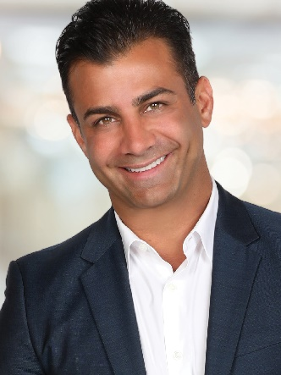
Harma Hartouni
Operating Principal, Broker, GRI, CRS
Keller Williams Realty

With eighteen years of experience in real estate, Harma began his career in development and new construction condominiums, while building his own real estate team. Working through market shifts in Southern California, Harma gained experience working with multiple financial institutions, servicing their bank-owned property/REO departments.
In 2009, Harma became owner of multiple Keller Williams Franchises in the Los Angeles area, and in 2017, as Operating Principal his combined offices grew to over 900 agents with a record $2.5B in volume. Harma and his real estate team services the greater Los Angeles and San Fernando Valley areas, focusing on Hollywood Hills, West Hollywood and surrounding cities, closing over 1300 transactions himself since being in business. Harma’s team has consistently ranked #1 in Southern California in both units closed and volume.
Harma has also successfully overseen the launch of multiple ancillary businesses including Escrow and Natural Hazard Disclosure, while building his knowledge and expertise of the economy, the real estate market and trends, and actively coaches multiple top agents – delivering a robust marketing strategy and high level of customer service to their individual clients.
Harma holds multiple real estate designations including Graduate Realtor Institute, Certified Residential Specialist, Real Estate Broker, Luxury Home Certification and Certified REO Broker. Among awards and honors received are Top Team in Keller Williams, National Association of Realtors “30 Under 30” and Los Angeles Business Journal “40 Under 40.”
https://www.harmahartouni.com/ - Getting Back Up, A Story of Resilience, Self-Acceptance and SUCCESS!
https://www.harma.com/

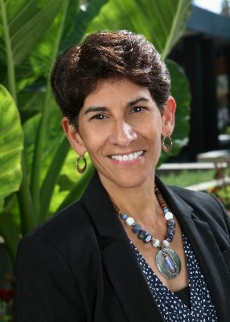
Martha I. Jimenez
Executive Vice President/General Counsel
The California Endowment

Martha I. Jimenez joined The California Endowment as Executive Vice President/General Counsel in October 2014. Her responsibilities include serving as chief advisor to The Endowment’s President and CEO, the Board of Directors and staff on legal and governance matters.
Additionally, Ms. Jimenez chairs the President and CEO’s Executive Team and leads the foundation’s organizational and operational effectiveness and strategy efforts, including the Office for Planning and Integration, Facilities, Center for Healthy Communities Conference Centers, and Administrative Grant-Making functions.
Prior to joining The Endowment, Ms. Jimenez served as Senior Counsel for Los Angeles County Supervisor Gloria Molina, having also served in that office as the Director of Legal and Health Programs. As Senior Counsel, she was responsible for providing guidance and recommendations to the Supervisor and her staff on legal strategy, policy development, and risk management issues. The First Supervisorial District is responsible f or representing the interests of over two million Los Angeles County residents living in 24 cities, 26 unincorporated areas and 16 areas of the City of Los Angeles.
Additionally, Ms. Jimenez served as Vice President for Policy and Development for Fair Trade USA where she advocated for “fair trade” practices that support farmers in developing countries by working with U.S.-based businesses; as a Program Of f icer with the Rockefeller Foundation and The California Endowment; as a Managing Attorney with Public Advocates and an Executive Director of the Latino Coalition for a Healthy California; and as a civil rights attorney with the Mexican American Legal Defense and Educational Fund (MALDEF) based in Washington, D.C. and Regional Counsel based in San Francisco.
Ms. Jimenez received her J.D. from the University California, Berkeley School of Law and her undergraduate degree from the University of Notre Dame.
https://www.calendow.org/

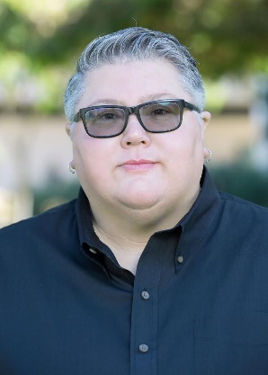
Leslie Thompson
Director of Operations, Economic and Workforce Development
Pasadena City College

Leslie Thompson is the Director of Operations for Economic and Workforce Development at Pasadena City College. She has worked at Pasadena City College for 25 years, serving in various positions under both Business Services and Economic and Workforce Development. Under the office of Economic and Workforce Development, Leslie oversees successful implementation and execution of a variety of initiatives under the office of EWD and serves as the project manager on these initiatives.
Prior to joining the EWD team, Leslie served 10 years as the College’s Bookstore Manager, where she was responsible for directing a team to plan, manage, evaluate and drive improvements for the self-supported business unit with annual sales in excess of $4.5M. She has a master’s degree in Human Development with specialization in Leadership in Education from Pacific Oaks College and a bachelor’s degree from Occidental College.
https://pasadena.edu/community/economic-workforce-development/index.php
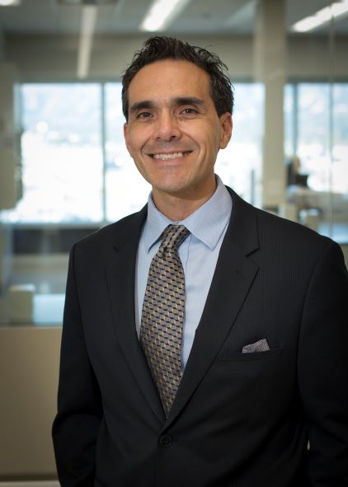
Obed Varela
Director of Environment, Health & Safety (EH&S)
Takeda

Obed Varela is the Director of Environment, Health & Safety (EH&S) for Takeda’s largest plasma fractionation site in Los Angeles and an associated Logistics and Distribution Site in Van Nuys. Obed has a Bachelor of Science in Microbiology and Chemistry from the University of Texas at El Paso and a Master of Science in Environmental and Occupational Health from California State University Northridge.
Obed is a Certified Safety Professional (CSP), a Certified Hazardous Materials Manager (CHMM) and a Registered Environmental Health Specialist (REHS). Obed grew up, allegedly, mostly in West Texas and made his way West to California in 1999. His family includes Marseille (12), Amelie (10), wife Jennifer (age withheld for very good reasons), Guero (4) a poodle-terrier mix, and Canela (3) a chihuahua.
When not working on all things EH&S Obed enjoys long bike rides with friends, lifting weights, fixing things around the house, or eating spicy Tonkotsu ramen with the girls.
https://www.takeda.com/en-us/

This event is hosted by Glendale Community College’s:
Pride Center & Career Services

Link to GCC Pride Center: https://www.glendale.edu/students/student-services/multicultural-community-engagement-center-mcec/pride-center

Link to GCC Career Services: https://www.glendale.edu/students/student-services/career-center

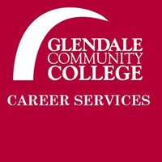
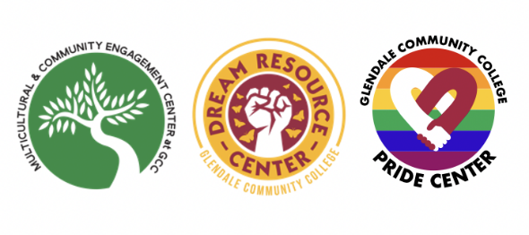
Thanks for joining us today. Stay connected!

