How do I add users to a course?

Open People
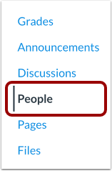
In Course Navigation, click the People link.

Add People
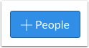
Click the Add People button.

Search by Email
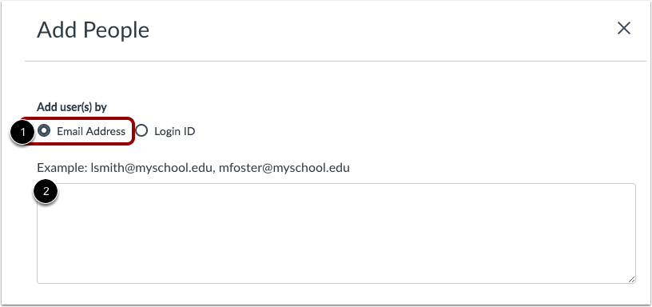
Enter the faculty evaluator’s GCC email address.

Select User Details
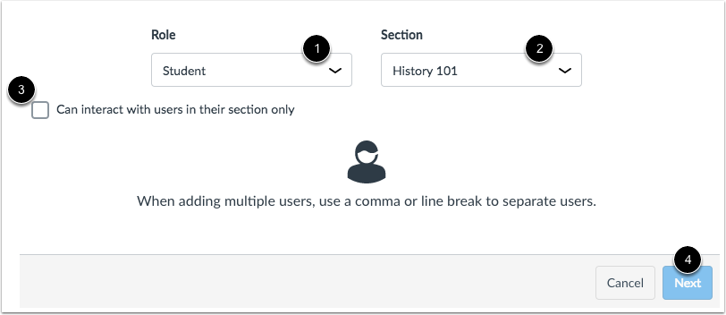
In the Role drop-down menu [1], assign the user(s) a role for the course based on available course roles. Select “Evaluator” Role.
In the Section drop-down menu [2], assign the user(s) a section in the course.
If you want to limit the user(s) to only interact with other users in their section, click the Can interact... checkbox [3].
Click the Next button [4].

Add Existing Users
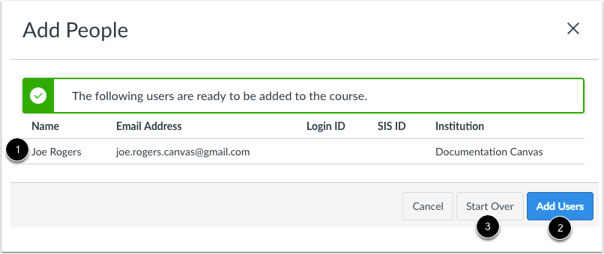
If Canvas finds an existing user, you can confirm the user before adding the user to the course [1].
The user's name displays in the page along with the user's information you used in the user search. Although Canvas may display additional search columns, existing information in a user's account will not be displayed.
When you are ready, click the Add Users button [2].
If Canvas did not find your intended user, you can click the Start Over button [3].

Note: Once the user has accepted the course invitation, you can interact with the user in the course. You can also send messages to the user via Conversations.
If necessary, you may be able to edit a user's role in Canvas.
It could take up to 24 hours for users to receive their invitations. Canvas will not consider the user to be enrolled—and won't recognize the user anywhere in Canvas—until the invitation has been accepted. If necessary, you can resend course invitations.

