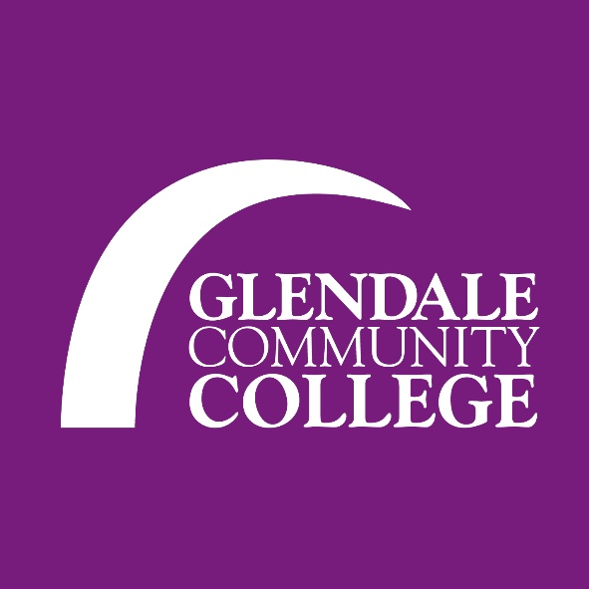
The Future of Dance Festival FESTIVAL SCHEDULE Saturday February 15, 2020

ALL PARTICIPANTS 10:00-10:25 am—Check-In/Registration Verification Sierra Nevada Building
10:25-10:27 am—Welcome Address—Sierra Nevada 104
10:28-10:30 am—Disperse to various master classes—Sierra Nevada
 | DANCE |  | DANCE LECTURE
10:30-  11:30 am | Master Class  Ballet Fusion  SN104-Victor Robles  Middle Eastern  SN 102-Tamra-henna Swan |  | Dance as Protest & Political Activism  SN101-Kory Wicks
11:30 am-12:30 pm | Master Class  Jazz Technique  SN104-Chelsea Asman  Salsa  SN 102-Ani Hovhannisyan |  | Dance on Film:  The Integration of Dance & Technology  SN101-Koryn Wicks
12:35- 1:45 pm | LUNCH
2:15-  4:00 pm | ADJUDICATION-SUBMISSION  SN 104
4:15-  4:30pm | ENCORE PRESENTATION  SN104

