Future of Dance
Saturday February 15, 2020
Glendale Community College

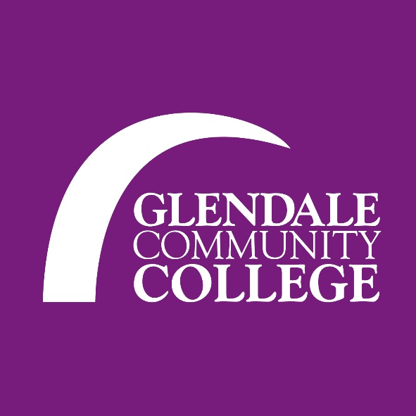

Adjudication Submission Information

Please provide the following details for each submission on a separate sheet (typed)

Organization Name:

Advisor:

E-mail:

Phone:

Submission Title:

Choreographer:

Style (Contemporary, Hip-Hop, Jazz, Cultural, etc.):

Length:

Dancers (alphabetical order):

