Glendale Community College
Distance Education Strategic
5-Year Plan

2018-2023

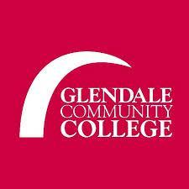

Approved by the Committee on Distance Education on Sept. 25, 2018

Approved by the Academic Senate on XXX, 2018

Approved by Academic Affairs on XXX, 20XX

Approved by the College Executive Committee on XXX, 20XX

Table of Contents


GCC DISTANCE EDUCATION STRATEGIC PLAN INTRODUCTION
- GCC Introduction of Distance Education Strategic Plan 3
- GCC Distance Education Mission, Vision and Core Values 5
- GCC Distance Education History and Growth 7

GCC DISTANCE EDUCATION STATISTICS
- GCC Distance Education Success and Retention Rates 13
- GCC Distance Education Compared to the CCC System 15

GCC DISTANCE EDUCATION STRATEGIC GOALS/OBJECTIVES
- GCC Distance Education 5-Year Plan (Goals/Objectives) 19
- GCC LMS, Management, Support, and Budget 36
- GCC Distance Education Alignment with the CVC-OEI 39

GCC DISTANCE EDUCATION LAWS REGULATIONS AND ACCREDITATION
- GCC Distance Education Laws Regulations at a Glance! 41
- GCC Distance Education Laws Regulation and Accreditation 43
- GCC Distance Education Definitions and Ticket Notes 47

GCC DISTANCE EDUCATION ACKNOWLEDGEMENTS AND APPENDICES
- Thank You to the DE Strategic Plan Task Force! 50

GCC Introduction of Distance Education Strategic Plan

The purpose of this Distance Education (DE) Strategic Plan is to recommend how to improve and increase quality distance education at Glendale Community College to best meet the students’ and community’s needs while providing strong support services to faculty. This DE Strategic Plan will establish common goals and criteria for quality online instruction, identify facilities, personnel, and infrastructure needs, set standards for training faculty and students, and make recommendations for DE faculty evaluation and course compliance checks. This plan will guide online instruction over the course of the next five academic years, 2018-2023, to ensure state and federal guidelines are current and implemented.

GCC’s online education program has grown both in numbers and quality over the past 10 years. This plan is designed to set direction for the college’s distance education program for the next five years, which includes: providing a quality program and increasing the course offerings, increasing possibilities for online program completion for students that need or prefer an online format, and alignment with directions from the District and the California Virtual Campus - Online Education Initiative (CVC-OEI).

The DE Strategic Plan reflects the Glendale Community College Mission, Vision and Master Plan. The purpose is to establish common goals and criteria for quality online instruction, identify facilities and infrastructure needs, set standards for training faculty and students, and make recommendations for faculty evaluation. This plan will guide online instruction over the course of the five academic years, 2018-2023, but will be evaluated bi-annually in the fall term by the Distance Education Strategic Plan Task Force of DE Certified Faculty (to be determined bi-annually), in conjunction with the Academic Senate. Updates will be available on the DE Policy & Procedure Website.

Developing the DE Strategic Plan is a three-step process:

- Planning: The current plan was created by a DE Strategic Plan Task Force, where participants determined DE Strategic Plan sections to be deleted, updated, or added. Suggestions for changes were documented. The Task Force chair, current Distance Education Coordinator, established a timeline and guided the preparation of the first draft of the DE Strategic Plan.

- Review: This first comprehensive draft was presented to the Committee on Distance Education (CoDE), for review and feedback.

- Final Revision and Approval: The DE Strategic Plan Task Force prepared the final draft of the plan based on the feedback collected during the CoDE review process. The final draft was then submitted for approval to the Academic Senate and will move forward through the governance process thereafter.

Due to the significant changes in the mode and instructional delivery of distance by the state of California and federal government, the DE Strategic Plan Task Force was formed as a sub-committee of CoDE to develop a comprehensive plan to meet instructional needs and changing DE policies. This Task Force met virtually and consisted of DE Certified Faculty that volunteered to review, discuss, and create the goals and objectives in this 5-Year Plan.

Gratitude is expressed to the creators of the Southwest College and Contra Costa College DE Strategic Plans. Rather than reinventing the wheel, we relied heavily on these two DE Strategic Plans in the initial development of our DE Strategic Plan.

GCC Distance Education Mission, Vision and Core Values

Distance Education Program Mission Statement

The Glendale Community College Distance Education Program Mission is to serve a diverse population of students by providing the opportunities and support to achieve their educational and career goals. The Distance Education Program is dedicated to the importance of higher education in the evolving urban environment of Glendale and the Greater Los Angeles area and beyond. Faculty and staff engage students in rigorous and innovative online learning experiences that enhance and sustain the cultural, intellectual, and economic vitality of the community. As part of its mission, Glendale Community College and the Distance Education Program are committed to student success by promoting:
- transfer preparation, certificates, associate degrees, career development, technical training, continuing education, and basic skills instruction;
- communication, critical thinking, information competency, quantitative reasoning, global awareness, personal responsibility, and application of knowledge;
- collaboration among disciplines and openness to the diversity of the human experience;
- student services, learning support, and technology that enable students to reach their educational goals in an efficient and timely manner;
- universally accessible, academically sound pedagogical strategies, and technologically advanced instruction at a distance, while responding to community needs and promoting faculty innovation;
- student retention by ensuring uniformity in terms of Learning Management System (LMS) and online instructor responsibility and accountability;
- clear expectations, guidelines and policies for instructors teaching distance education courses in order to adhere to the requirements of Title 5 Regulations, Federal ADA/Section 508 Laws, the American Federation of Teachers (AFT) Contract (Article 40), and the Accrediting Commission for Community and Junior Colleges (ACCJC) of the Western Association of Schools and Colleges (WASC) which oversees accreditation at Glendale Community College.

Distance Education Vision and Core Values Statement

The Glendale Community College Distance Education Program seeks to lead in educational excellence, innovation, training, delivery, and support of online and hybrid instructional modalities. Glendale Community College looks to participate in the Online Education Initiative (OEI) in order to provide our students, and those throughout California, with high-quality online courses.

The Distance Education Program at Glendale Community College is guided by the following Core Values:

- Leadership in technology, instructional innovation, and cultivation of lifelong learning and professional development;
- Dedication to best practices in distance education and support services for student success;
- Commitment to communication and collaboration among key stakeholders;
- Transparency in the decision-making process, while maintaining integrity and professionalism.

GCC Distance Education History and Growth

GCC Distance Education History:

- Glendale Community College is committed to providing students with options in delivery modalities of instruction. As faculty began increasing the use of technology in the classroom, the Academic Senate in cooperation with the administration, recognized the need for additional standards to ensure quality coursework.

- Initially, Technology Mediated Instruction (TMI), a governance committee under the purview of Academic Affairs, was established to ensure that Distance Education met the quality standards expected by the college. The Learning Management System was WebCT and then Blackboard under TMI.

- This TMI committee was a subcommittee of Academic Affairs and represented all campus constituencies. As a governance committee, with the required broad participation from all campus constituencies, it became clear that the concerns of the faculty and issues specific to andragogy were diluted.

- Therefore, the Academic Senate and the administration agreed to replace TMI with a subcommittee of the Academic Senate to establish an integrated program and plan for distance education and to focus on issues specific to andragogy. In order to create and lead a distance education program, an 80% faculty release-time position was approved – the Distance Education (DE) Coordinator. This faculty coordinator reported to the Academic Senate, Chaired CoDE, and was supervised by the Dean of Library and Support Services.

- In April 2011, the GCC DE Coordinator attended a webinar presented by ACCJC. The webinar explained the federal regulation and their impact on accreditation in Distance Education. The Distance Education Coordinator provided a brief on the webinar to the CIO and recommended a hiatus to DE growth at GCC in order to assess the delivery of instruction in Distance Education.

- On October 7, 2011, the Academic Senate approved the creation of a Distance Education (DE) Taskforce. The Taskforce was to develop a Distance Education Program at GCC.

- On April 7, 2012, the DE Taskforce established the Committee on Distance Education (CoDE). A DE 5-Year Plan was presented.

- On May 5, 2012, the Academic Senate approved CoDE as a Senate Committee. CoDE was held responsible for the development of new policies and procedures to align the program with accreditation standards.

- The purpose of CoDE is to ensure that the college’s distance education offerings are of the highest quality and are compliant with state and accreditation standards; furthermore, CoDE is tasked with defining standards and guidelines for all distance courses/programs.

- CoDE works with the DE Coordinator and existing instructional programs to facilitate and improve online technology and learning. Each committee member represents his/her division and acts as a resource to all faculty members regarding exploration, development, and implementation of strategies that ensure strong andragogy in the online venue. The CoDE committee membership consists of a faculty member from each division and a faculty coordinator who chairs the committee.

- In order to assess the DE Program at GCC, CoDE produced a Distance Education Inventory in October 2011 in which DE instructors participated via Survey Monkey. The results of the inventory provided the DE Coordinator the necessary areas of focus needed to improve the delivery of content and regular and effective contact in Distance Education.

- Campus-wide faculty meetings were used to address the federal regulation and their impact on accreditation. In addition, CoDE developed DE Authentication Policies and an updated DE Course Addendum, which would enable new DE courses to maintain a compliant environment from the inception of the course. The Academic Senate approved the DE Course Addendum through the governance process on March 5, 2014.

- A Substantive Change Report for DE was submitted on March 18, 2014. This proposal for substantive change of programs at Glendale Community College was submitted to the ACCJC to seek approval for programs and certificates that can be completed 50% or more through Distance Education at GCC through the LMS, Moodle.

- Policies and procedures for authentication, faculty/student interaction, attendance, participation, and training have been developed and approved by the Academic Senate and Academic Affairs.

- All courses offered in DE are approved by CoDE through the DE Addenda. Divisions, Curriculum & Instruction (C&I), Academic Affairs, Campus Executive, and the Board of Trustees, must approval all new and revised courses/programs.

- A faculty training/certificate program for Distance Education was developed for the purpose of ensuring quality and compliance with DE state regulations, federal laws, and accreditation guidelines. Before the fall of 2014, there were no training procedures for faculty. However, the Committee on Distance Education (CODE) developed and approved an in-house training program. It was designed and monitored by the DE Coordinator. All faculty who wanted to teach online were asked to complete 20% of their total required annual Flex hours on Distance Education topics (This was typically 6 hours for a full-time faculty member and 3 hours for a part-tie faculty member).

- Expectations for all online instructors include class participation, course design, and activities compliant with the Guide to Evaluating Distance Education and Correspondence Education (ACCJC, June 2014). Faculty certification was designed to ensure that instructional design is compliant and not Correspondence Education.

- In fall of 2015, a Full Program Review was submitted for Distance Education. Topics covered were: assessments with programs, courses, and cycles; DE program evaluation and needs. In sum, the DE program at GCC was understaffed. An Instructional Support Specialist and DE Coordinator were not enough to fulfill the high demands of the DE program. An accessibility specialist to comply with federal ADA/508 requirements was requested, along with an Instructional Designer to further aid in the development and creation of quality online courses.

- In anticipation of the DE Coordinator stepping-down in spring 2017, the Academic Senate divided the 80% faculty release-time position into three positions: DE Coordinator (50%) DE Faculty Development Coordinator (30%), and @ONE Faculty Trainer (20%).

- In spring 2017, the DE Coordinator stepped-down. A replacement started in fall 2017 but stepped down at the end of the year. The Interim DE Coordinator began in spring 2018, along with becoming the @ONE Faculty Trainer. Also in spring 2018, the position of DE Faculty Development Coordinator began. In fall 2018, interim DE Coordinator was reconfirmed the 2-year position.

- The DE Faculty Development Coordinator is responsible for all DE faculty development opportunities at GCC by way of workshops, training, leading the Community of Practice and offering faculty assistance in course design, pedagogy, and Online Education Initiative (CVC-OEI) “ready” courses for the exchange.

- This DE Faculty Development Coordinator position also oversees the Glendale Annual DE Recertification (GADER) hours earned by DE faculty in order to stay DE instructor Eligible. Full-time faculty need to complete 6-hours annually and part-time faculty need to complete 3-hours annually of GADER. This position chairs the GADER committee, is a Resource on CoDE, and works closely with the academic senate and the Instructional Support Specialist on the effective use of the LMS, Canvas.

- The DE Coordinator is responsible for the strategic use of institutional data and participation in Program Review: assesses the effectiveness of DE planning; makes recommendations for sustained continuous quality improvement in DE; develops strategies to promote college-wide dialogue and participation in the integrated planning process for growth in DE; and identifies trends that reveal institutional and student needs in DE, organizes and chairs a minimum of one meeting per month of the Committee on Distance Education (CoDE) during Fall and Spring semesters, works closely with the academic senate, division chairs, DE course scheduling, upholds accreditation standards and facilitates the creation of DE policy and procedure.

- In fall 2017, CoDE recommended updating the training requirement for faculty to become certified to teach DE classes at GCC. The requirement changed from 6-hours to completing a 40-hour Introduction to Online Teaching and Learning (IOTL) @ONE adopted course. This adopted and customized GCC IOTL course is to be facilitated by the @ONE Faculty Trainer – free to faculty with either a 1.25 step-in column incentive or 40 hours of Flex, starting in January 2018.

- Canvas has given GCC a greater capacity to serve our students. Canvas offers 24/7-telephone support for both faculty and students, which helped in the ability to train and acclimate faculty and students to this new LMS. This has also freed up time for GCC's Instruction Support Specialist to spend more one-on-one time with faculty in building, designing, and crafting their online/hybrid courses. This Specialist offers regular year-round on-campus workshops on how to use Canvas, other instructional support tools and software, and technical support beyond the 24/7-telephone support.

- In 2014, the California Community Colleges embarked on the Online Education Initiative (CVC-OEI), a collaboration that has the potential to affect online teaching and learning across the state. CVC-OEI seeks to enhance the quality of online courses in the CCC system, with the express goal of increasing student success and transfer rates.

- In April 2018, GCC was accepted into the second CVC-OEI Online Equity Cohort, along with 32 other Community Colleges in California. This brings the total to 56 participating community colleges.
- In fall of 2018, The Online Education Initiative (OEI) merged with the California Virtual Campus (CVC) to now create the CVC-OEI.

- In fall of 2018, the second Full Program Review will be submitted for Distance Education. As stated in the 2015-2016 Full Program Review, the DE program at GCC is still understaffed to meet the high demands of this program. An Alternative Media Specialist and robust software (such as Ally by Blackboard) to help faculty comply with federal online ADA/508 requirements is requested. Also, imperative to the advancement of the DE program, an Instructional Designer and Canvas support specialist is needed to further aid in the development and creation of quality online courses.

GCC Distance Education Growth:

According to the GCC Research, Planning and Grants Department, overall growth in the number of online and hybrid course offerings are inconsistent over the last seven-years from fall 2011 to spring 2018. GCC DE course offerings were at its highest at 9.9% in fall 2011, but fluctuated up and down through the years and ended at 9.6% in spring 2018 (see chart 1. below).

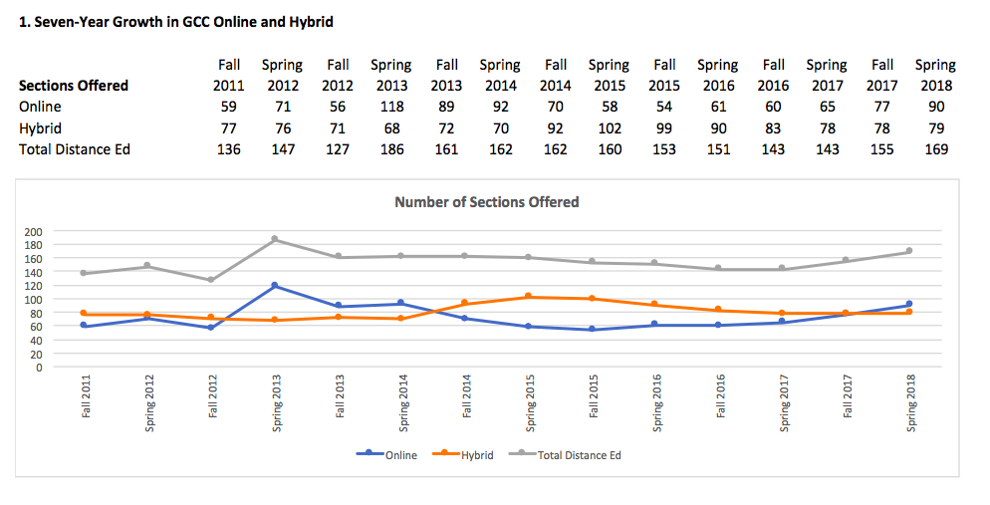
(1. Graph created by the GCC Research, Planning and Grants Department, August 2018)

GCC Distance Education Growth of FTES:

According to the GCC Research, Planning and Grants Department, overall growth rates in the number of Full-Time Equivalent Students (FTES) taking online and hybrid courses has moderately decreased from Fall 2011 to spring 2018 (see chart 6. below).

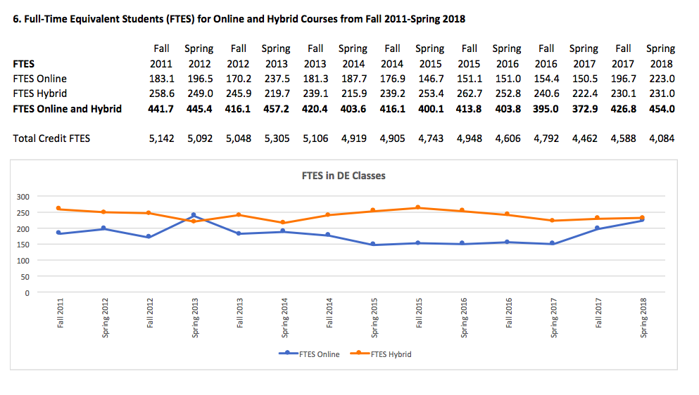
(6. Graph created by the GCC Research, Planning and Grants Department, August 2018)

GCC Distance Education Percentage of Students Taking DE Courses:

According to the GCC Research, Planning and Grants Department, the percentage of GCC college students taking at least one online or hybrid course has increased from 8.2% to in Fall 2011 to 11.5% in spring 2018 (see chart 13. below).

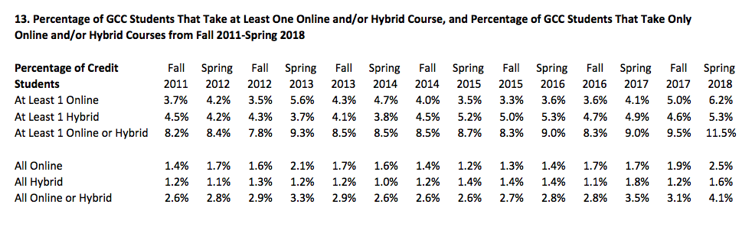
(13. Graph created by the GCC Research, Planning and Grants Department, August 2018)

GCC Distance Education Success and Retention Rates

GCC Distance Education Success Rate and Retention Rate Trends:

According to the GCC Research, Planning and Grants Department, overall student success rates in online and hybrid courses rose from fall 2011 to spring 2018. Since Spring 2013, Hybrid courses at GCC have earned a higher success rate than both online and face-to-face (traditional) courses at GCC. Online courses at GCC have consistently earned lower success rates than both hybrid and face-to-face (traditional) courses at GCC, but the success gap is closing from 57% in Fall 2011 to 68.5% in Spring 2018 (see chart 2. below).
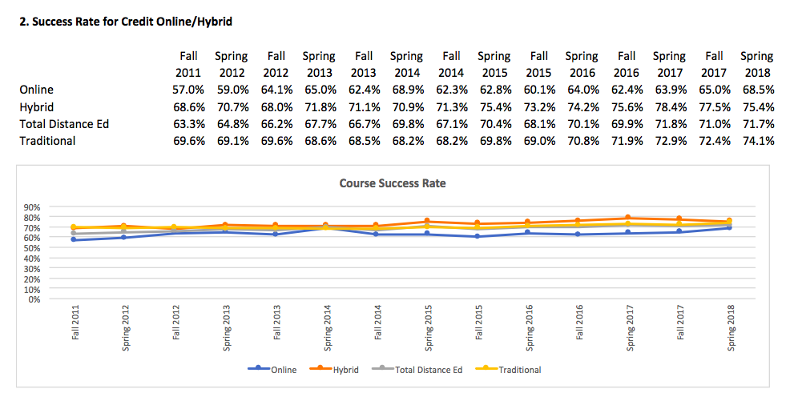
(2. Graph created by the GCC Research, Planning and Grants Department, August 2018)

According to the GCC Research, Planning and Grants Department, overall retention rates in online and hybrid courses rose from fall 2011 to spring 2018. Since Spring 2013, Hybrid courses at GCC have earned an equal or higher retention rate than face-to-face (traditional) courses, and a higher rate than online courses at GCC. Online courses at GCC have consistently earned lower success rates than both hybrid and face-to-face (traditional) courses at GCC, but the success gap is closing from 77.7% in Fall 2011 to 81.8% in Spring 2018 (see 10. chart below).

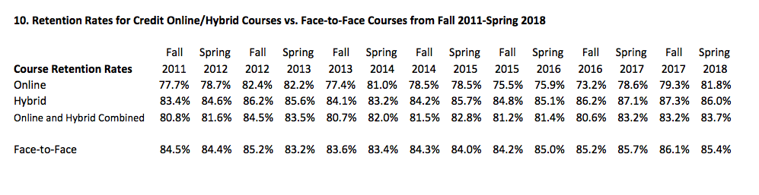
(10. Graph created by the GCC Research, Planning and Grants Department, August 2018)

According to the GCC Research, Planning and Grants Department, GCC students who took “some online or hybrid” courses had a higher transfer percentage rate to a four-year institution than students took none, one, most or all online and hybrid courses from 2011-2012 (see 18. chart below).
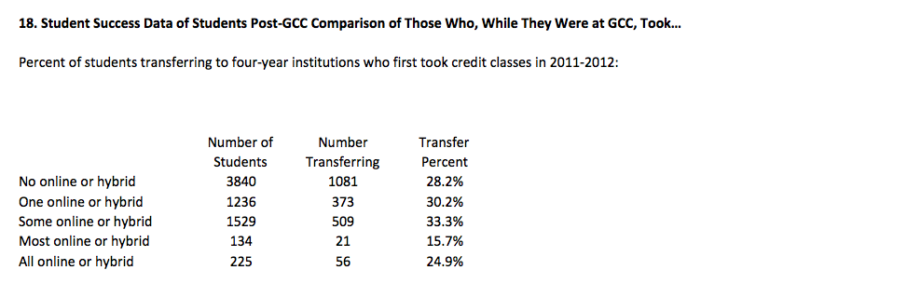
(18. Graph created by the GCC Research, Planning and Grants Department, August 2018)

GCC Distance Education Compared to the CCC System

An important part of California higher education is Distance Education (DE). The California Community College (CCC) system is the largest provider of distance education offerings (Distance Education Report, 2017, p.9) of the states’ three public higher education systems. Among the California Community Colleges, there was an overall enrollment growth in distance education sessions that exceeded growth in traditional face-to-face courses by over 28%, according to the Chancellor’s Office 2017 Distance Education Report, from 2005 to 2017 (p.20).

Growth is fueled by demand. Students with ubiquitous access to the web and mobile technologies value, and expect, the convenience of access to course content anywhere, anytime. This expectation has been met by the adoption of asynchronous communication methods for course delivery. According to the Chancellor's Office, "Online instruction using asynchronous time based delivery is by far the most widely used method of conducting distance education because it offers students the greatest flexibility in taking courses. Currently 94 percent of all distance education courses are internet-based courses (87 percent asynchronous, 7 percent synchronous" (Distance Education Report, 2017, p.37).
California state survey results show that higher education students select distance education courses because internet-based courses facilitate access and equity to a college education and incorporate more easily within other aspects of their lives. A flexible learning schedule permits students to arrange work, family, and other personal obligations to suit their individual needs. Students take distance education courses because they provide a more convenient way to manage both a heavy work schedule and personal and/or family needs. “California Community College distance education student survey data in fall 2016 indicates that convenience (at 60%) is the number one reason why students take a course” (Distance Education Report, 2017, p.31).

GCC Distance Education Growth Compared to the CCC system:

According to the GCC Research, Planning and Grants Department, overall growth rates in the number of online and hybrid course offerings are inconsistent over the last seven-years from fall 2011 to spring 2018. GCC DE course offerings were at its highest at 9.9% in fall 2011, but fluctuated up and down through the years and ended at 9.6% in spring 2018. In contrast, the overall growth rate in the number of online and hybrid course offerings in the CCC system rose steadily from 9% in fall 2011 to 15.6% in spring 2018 (see chart 14. below).

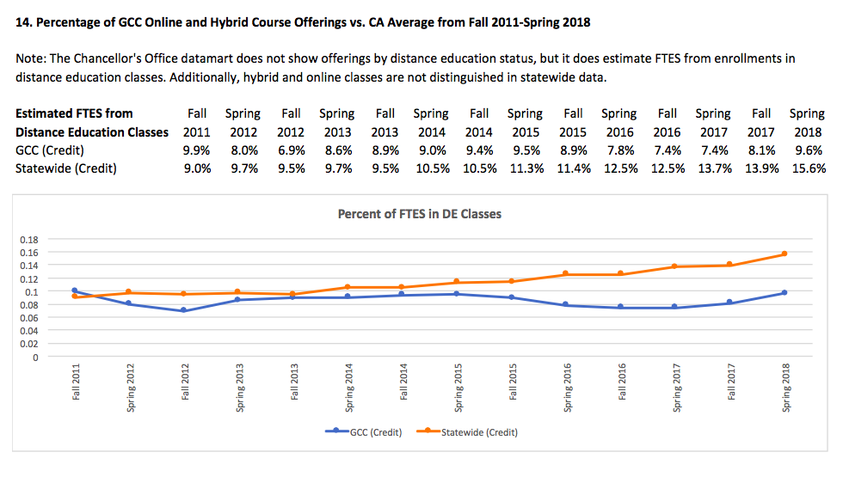
(14. Graph created by the GCC Research, Planning and Grants Department, August 2018)

GCC Distance Education Success Rates Compared to the CCC system:

According to the GCC Research, Planning and Grants Department, overall student success rates in distance education courses rose from fall 2011 at 63.9% to spring 2018 at 71.2%. Although Online courses at GCC have consistently earned lower success rates than both hybrid and face-to-face (traditional) courses at GCC from fall 2011 to spring 2018, the overall success rate of distance education courses in the CCC system are significantly lower that that of GCC rates from fall 2011 at 58.4% to spring 2018 at 68.1% (see chart 15. below).

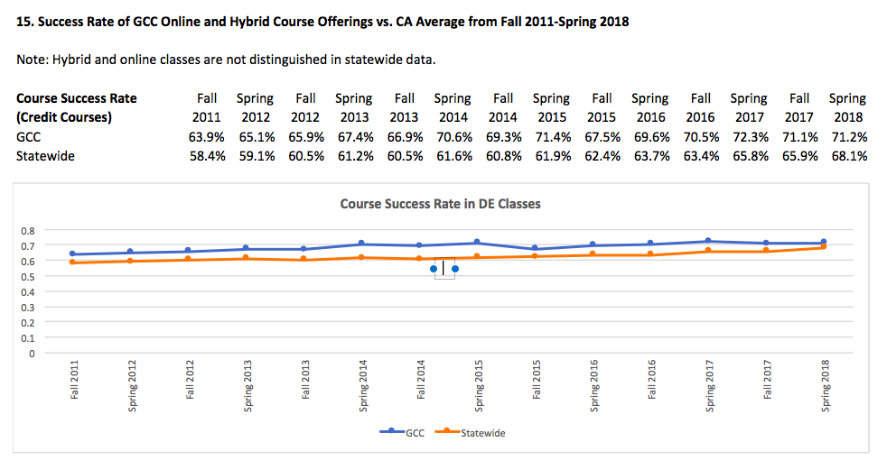
(15. Graph created by the GCC Research, Planning and Grants Department, August 2018)

GCC Distance Education Retention Rates Compared to the CCC system:

According to the GCC Research, Planning and Grants Department, overall retention success rates in distance education courses rose from fall 2011 at 81.8% to spring 2018 at 83.9%. The overall retention rate of distance education courses in the CCC system have steadily risen from fall 2011 at 78.1% to spring 2018 at 84.2%. This rise in retention has paralleled GCC retention rates slightly in fall 2015/spring 2016 and surpassed GCC retention rates by .03 in spring 2018 (see chart 16. below).

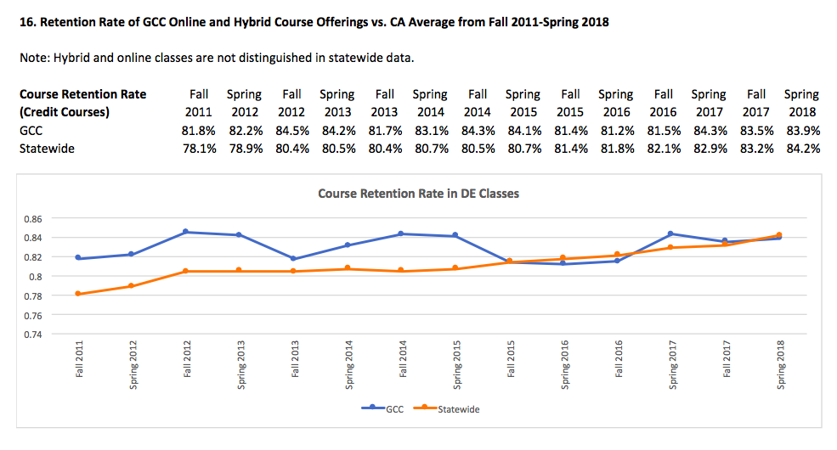
(16. Graph created by the GCC Research, Planning and Grants Department, August 2018)

GCC Distance Education 5-Year Plan (Goals/Objectives)

GCC Distance Education Goals/Objectives

GCC’s Distance Education (DE) Goals and Objectives aim to direct the program’s development and improvement process. The DE Program at GCC is committed to offering only those new products and services that can be fully supported and funded with the technical, financial, and staffing resources available. The Committee on Distance Education and the Academic Senate will revisit the Goals and Objectives in this plan every two years as DE state regulations, federal laws, and accreditation guidelines change.

Specific points, acknowledgments, and concerns facing Distance Education as indicated in the Glendale Community College Institutional Master Plan 2018-2023.

To fulfill its DE Mission and to be consistent with its Vision and Core Values, Glendale Community College is committed to the following DE Program Goals and Objectives over the next five academic years:

DE Goals:

The 8 DE Goals align with the GCC Institutional Master Plan 2018-2023D.5

- Goal 1: Develop and Promote Principles of Excellence in DE Program Quality
- Goal 2: Develop and Promote Principles of Excellence in DE Course Quality
- Goal 3: Expand DE growth and DE faculty Participation Opportunities
- Goal 4: Enhance DE Professional Development Opportunities
- Goal 5: Maximize the use of Canvas capabilities to improve the quality of our Online offerings
- Goal 6: Collaborate to Expand Student Support Services for DE Students
- Goal 7: Collaborate with ITS to Improve Technology Infrastructure, Resources, and Support for Coordination and Continuous Improvement
- Goal 8: Meet all Requirements of Participation in the CVC-OEI Cohort

Goal 1: Develop and Promote Principles of Excellence in DE Program Quality

Maintain a quality DE program through continuous program improvement based on the review and assessment of instruction, procedures, policies, practices, and accessibility. This goal includes objectives that will address the support necessary to create and sustain a quality DE program at GCC.

Goal 1: Objectives

- Encourage all newly hired faculty who will be teaching an online or hybrid course to meet with the DE Coordinator (DEC) and/or DE Faculty Development Coordinator (DEFDC) for review of college expectations and training opportunities.
  - Person(s) Responsible: DEC and/or DEFDC
  - Fiscal Resources Needed: None (within job duties)
  - Estimated Timeframe: Fall 2018-Spring 2023

- DEC and DEFDC will work closely with Division Chairs to ensure open communication, respect and collaboration of ideas to promote a high-quality distance education program at GCC.
- Person(s) Responsible: DEC and DEFDC
- Fiscal Resources Needed: None (within job duties)
- Estimated Timeframe: Fall 2018-Spring 2023

- Work towards creating 100% online certificates.
- Person(s) Responsible: DEC/DEFDC/Campus-Wide Support
- Fiscal Resources Needed: Campus-Wide Collaboration/Fiscal TBD
- Estimated Timeframe: Fall 2018-Spring 2023

- Work towards creating 100% online transferable degrees.
- Person(s) Responsible: DEC/DEFDC/Campus-Wide Support
- Fiscal Resources Needed: Campus-Wide Collaboration/Fiscal TBD
- Estimated Timeframe: Fall 2018-Spring 2023

- Develop DE Guided Pathway for completing transfer requirements with online courses and other DE guided pathway information for students.
- Person(s) Responsible: DE Guided Pathway Rep and DEC
- Fiscal Resources Needed: None (within job duties)
- Estimated Timeframe: Fall 2018-Spring 2023

- Continue growth of online course offerings to meet student and community demands by conducting surveys of students and of the community to learn the wants and needs for online education courses.
- Person(s) Responsible: DEC and DEFDC
- Fiscal Resources Needed: None (within job duties)
- Estimated Timeframe: Fall 2018-Spring 2023
- Continue to work with the Curriculum + Instruction (C&I) Committee to ensure transparency and flow of information between the DE Addendum process and Curriculum Management System, per Title 5 Regulations.
- Person(s) Responsible: DEC and C&I Coordinator
- Fiscal Resources Needed: None (within job duties)
- Estimated Timeframe: Fall 2018-Spring 2023

- Ensure that all DE courses are following measurable Student Learning Outcomes (SLOs), as outlined in the Curriculum of Record (COR) and are regularly accessing these outcomes within their DE courses, per state and Curriculum and Instruction (C&I) guidelines.
- Person(s) Responsible: DEC, C&I Coordinator and Division Chairs
- Fiscal Resources Needed: None (within job duties)
- Estimated Timeframe: Fall 2018-Spring 2023

- In collaboration with the Guild and Academic Senate, create a DE Instructor Evaluation Form and process to effectively measure the effectiveness of online teaching practices and compliance with DE state regulations, federal laws, and accreditation guidelines.
- Person(s) Responsible: DEC, DEFDC, Senate/Guild, Dean of Library
- Fiscal Resources Needed: None (within job duties)
- Estimated Timeframe: Fall 2018-Spring 2020

- REPEATED IN GOAL 2: OBJ 5 - In collaboration with the Guild, create a DE Course Compliance Checklist and process in conjunction with the Academic Senate approved OEI Course Design Rubric to measure a DE course effectiveness of online teaching practices and compliance with state and federal DE guidelines.
- Person(s) Responsible: DEC, DEFDC, Senate/Guild, Dean of Library
- Fiscal Resources Needed: None (within job duties)
- Estimated Timeframe: Fall 2018-Spring 2019

- Create and encourage a DE end-of-course survey for all DE students to complete in order to gather data on the effectiveness of course delivery and retention/persistence to make future DE program recommendations.
- Person(s) Responsible: FDC, DEFDC, DEC, Title 5 Grant Manager
- Fiscal Resources Needed: None (within job duties)
- Estimated Timeframe: Fall 2018-Spring 2020

- Done - Invite a Guided Pathways and Student Equity committee member to join the Committee on Distance Education (CoDE) as a resource to ensure all voices are being heard during the creation and recommendation process of DE policy and procedures.
- Person(s) Responsible: DEC
- Fiscal Resources Needed: None (within job duties)
- Estimated Timeframe: Fall 2018-Spring 2019
- Find representation to sit on CoDE, as a voting member or resource, from the Academic Senate and Open Education Resources (OER), Done - Guild, Guided Pathways, SLO and Student Equity, to ensure that these voices are heard when making important decisions.
- Person(s) Responsible: DEC
- Fiscal Resources Needed: None (within job duties)
- Estimated Timeframe: Spring 2018-Fall 2020

- Expand and promote the role of DE Division Mentors to provide individual and small-group mentoring for faculty teaching online or preparing to teach online. Increase awareness of the DE Mentor Program through Division outreach, CoDE Representatives, CVC-OEI/GADER Subcommittee, email, and integration into current DE training and faculty development opportunities.
- Person(s) Responsible: DEC and DEFDC
- Fiscal Resources Needed: None (within job duties)
- Estimated Timeframe: Fall 2018-Spring 2023

Goal 2: Develop and Promote Principles of Excellence in DE Course Quality

Maintain quality DE course content offerings through continuous faculty training in effective course design, online pedagogy and best practices based on the continued monitoring and revising of DE state regulations, federal laws, and accreditation guidelines. This goal includes objectives that will address the support necessary to create and sustain quality online course offerings at GCC.

Goal 2: Objectives

- Hire a full-time Instructional Designer to aid in the goal of increased quality within DE course design as supported by the CVC-OEI Course Design Rubric and other recognized state regulations, federal laws, accreditation guidelines, and effective DE practices.
  - Person(s) Responsible: Dean of Library, VPI
  - Fiscal Resources Needed: Institutional Funding
  - Estimated Timeframe: Fall 2018-Spring 2020

- Hire an Alternative Media Specialist and/or individual that can assist with Canvas technical support, with knowledge of universal course design, accessibility issues and solutions, and training support on pedagogy through the support of the CVC-OEI Course Design Rubric if desired.
- Person(s) Responsible: Dean of Library, VPI
- Fiscal Resources Needed: Institutional Funding
- Estimated Timeframe: Fall 2018-Spring 2020

- Hire/Contract for expert help for faculty with creating accessible (ADA/508) courses and content by the adoption of “Ally by Blackboard” software and/or a trained accessibility expert. Work closely with Disabled Students Programs and Services (DSPS), Student Support Services, and Information Technology Services (ITS) to ensure compliance and regulatory updates and integration into online courses.
- Person(s) Responsible: DEC, Senate, Deans, VPI, Division Chair
- Fiscal Resources Needed: Institutional Funding
- Estimated Timeframe: Fall 2018-Spring 2023

- Promote the CVC-OEI Course Design Rubric and provide faculty-training for use as a best practice for excellence.
  - Person(s) Responsible: DEC, DEFDC, CoDE, @ONE Faculty Trainer
  - Fiscal Resources Needed: None (within job duties)
  - Estimated Timeframe: Fall 2018-Spring 2023

- Continue to promote and improve the Introduction to Online Teaching and Learning (IOTL) in-house online pedagogy/course design training requirement to become DE certified at GCC. Offer more sections, if warranted, to ensure that all faculty interested in becoming DE certified at GCC have the opportunity to do so free of charge.
- Person(s) Responsible: @ONE Faculty Trainer
- Fiscal Resources Needed: None (within job duties)
- Estimated Timeframe: Fall 2018-Spring 2023

- In consultation with the Guild, broaden initial DE certification training requirements to 8-12 6-12 weeks so accessibility, course design, equity, regular and substantive interaction, and other pertinent pedagogy can be explored past the introduction to online teaching and learning course that covers only the ‘basics’ of teaching in the online environment.
- Person(s) Responsible: DEC, Senate, Deans, VPI, Division Chair
- Fiscal Resources Needed: Institutional Funding
- Estimated Timeframe: Fall 2018-Spring 2023

- DONE - Create a DE Listserv and/or Canvas Course Shell to better communicate Canvas issues, solutions, patches, new releases, beta testing, tips/tricks, DE issues, policies, procedures, and new ideas amongst DE certified faculty.
- Person(s) Responsible: DEC and DEFDC
- Fiscal Resources Needed: None (within job duties)
- Estimated Timeframe: Fall 2018-Spring 2019

- In collaboration with the Academic Senate, create a DE Course Compliance Checklist review process with the Academic Senate approved CVC-OEI Course Design Rubric to ensure that DE courses are meeting the minimum DE state (Title 5) regulations, federal laws (ADA/508/FERPA) and accreditation guidelines in preparation for Accreditation, Program Review, and Department of Education visits, audits, and/or reviews.
- Person(s) Responsible: DEC, DEFDC, Senate, CVC-OEI Subcommittee
- Fiscal Resources Needed: None (within job duties)
- Estimated Timeframe: Fall 2018-Spring 2020

Goal 3 Expand DE growth and DE faculty Participation Opportunities

Provide greater opportunities for GCC faculty to participate in the successful development of a vibrant and high-quality distance education program. This goal includes objectives that will ensure opportunities for GCC faculty to become DE Certified to design and teach DE courses through the CVC-OEI and/or to GCC students, along with increasing overall participation in the development of a solid DE program and course offerings.

- Plan and create a Peer Online Course Review (POCR) program for and with faculty to participate in the local review of online courses in preparation to participate in the Consortium.
  - Person(s) Responsible: DEC, DEFDC, Senate, Deans, CoDE
  - Fiscal Resources Needed: None (within job duties)
  - Estimated Timeframe: Fall 2018-Spring 2023

- Seek funding for greater incentives to encourage faculty to submit their courses to the CVC-OEI Design Academy and to create a “CVC-OEI Ready Online Course” to run in the exchange. Offer stipend pay, instructional tools or software, banked units, first right of refusal, sabbaticals, reduced course load or greater units for a DE course, TAs to help with grading difference with F2F classes, higher pay rate, etc.
  - Person(s) Responsible: DEC, DEFDC, Senate, Deans, Guild, CoDE
  - Fiscal Resources Needed: Institutional Funding/Division Funding
  - Estimated Timeframe: Fall 2018-Spring 2023

- Provide incentives for DE faculty to become POCRs and aid in the facilitation of DE course compliance checks and/or mentor other faculty in teaching online or preparing to teach online – offer stipend pay, instructional tools or software, banked units, etc.
  - Person(s) Responsible: DEC, DEFDC, Senate, Deans, CoDE
  - Fiscal Resources Needed: Institutional Funding/Division Funding
  - Estimated Timeframe: Fall 2018-Spring 2023

- OFFERED THROUGH PD - Guaranteed faculty reimbursement for @ONE 4-week courses ($65) – Not IOTL that is offered free to GCC faculty – or @ONE 12-week courses ($150) on Design Fundamentals or Online Teaching Principles to promote principles of excellence in online course delivery.
- Person(s) Responsible: DEC, DEFDC, CoDE, Senate, Deans, VPI
- Fiscal Resources Needed: Institutional Funding/Division Funding
- Estimated Timeframe: Fall 2018-Spring 2023

- In collaboration with administration, offer a stipend/banked units/release time to a DE Certified faculty member to create a distance education “Master Shell” – CVC-OEI Aligned/Design Academy Approved course– to be used as a base for other DE Faculty that wish to teach the class online and/or enter the Design Academy for CVC-OEI Exchange approval.
  - Person(s) Responsible: DEC, DEFDC, Deans, VPI
  - Fiscal Resources Needed: Institutional Funding/Division Funding
  - Estimated Timeframe: Fall 2018-Spring 2023

- Research and implement an attendance accounting process to bring non-credit courses into the distance education department for growth and faculty opportunities.
  - Person(s) Responsible: DEC, DEFDC, Senate, Deans, VPI, Chairs
  - Fiscal Resources Needed: Division Funding
  - Estimated Timeframe: Fall 2018-Spring 2023

Goal 4: Enhance DE Professional Development Opportunities

Provide comprehensive and robust faculty training and continued DE professional development for successful distance education instruction. This goal includes objectives that will ensure that DE-trained instructors are teaching GCC’s online and hybrid courses through the completion of quality DE professional development opportunities.

Goal 4: Objectives

- Offer Glendale Annual DE Recertification (GADER) hours, stipends, banked-units or another incentive to encourage a self-evaluation using the CVC-OEI Course Design Rubric, engaging in Peer Online Couse Review (POCR) training, and/or providing course peer feedback for DE Certified faculty using the CVC-OEI Course Design Rubric.
  - Person(s) Responsible: DEC, DEFDC, CoDE, Senate, Deans, VPI
  - Fiscal Resources Needed: Institutional Funding/Division Funding
  - Estimated Timeframe: Fall 2018-Spring 2023

- Offer a greater quantity of workshops and training schedule, utilizing the DE faculty talent on the GCC campus, to facilitate training for faculty on incorporating technology tools and best practices to enhance teaching effectiveness.
  - Person(s) Responsible: DEFDC
  - Fiscal Resources Needed: None (within job duties)
  - Estimated Timeframe: Fall 2018-Spring 2023

- Continue to provide existing training and expand as appropriate to meet the needs of faculty; for example, Community of Practice synchronous and asynchronous learning sessions, a “Tech-Fest” or full-day, 6-hour workshop of integrating the CVC-OEI Rubric into an online course design.
- Person(s) Responsible: DEFDC
- Fiscal Resources Needed: None (within job duties)
- Estimated Timeframe: Fall 2018-Spring 2023

- Create a set of training sessions on how to decrease the performance gap between face-to-face and online courses through effective course design, engagement with equity, and using regular and substantive contact in the online teaching environment, while meeting DE state regulations, federal laws, and accreditation guidelines.
- Person(s) Responsible: DEFDC
- Fiscal Resources Needed: None (within job duties)
- Estimated Timeframe: Fall 2018-Spring 2023

- Increase online, asynchronous training and workshops for adjuncts and full-time faculty that are unable to attend face-to-face DE training, but wish to engage in an active community of practice with other DE certified faculty at GCC.
  - Person(s) Responsible: DEFDC
  - Fiscal Resources Needed: None (within job duties)
  - Estimated Timeframe: Fall 2018-Spring 2023

Goal 5: Maximize the use of Canvas capabilities to improve the quality of our Online offerings

Although it is understood that the field of Distance Education is changing rapidly, and that documents created to address the fundamental policies of DE in the institution can never reflect all DE processes and policies with absolute currency, we have chosen to include specific, concrete examples of elements of goals and objectives in order to clarify the areas discussed below.

For example, when we state that one goal is to “create a set of mandatory guidelines” (Goal 5, Objective 3), we are referring here to guidelines required by CVC-OEI in order to participate in the OEI. Glendale College is one of the second-wave OEI colleges. Currently, (fall 2018), CVC-OEI requires that participating colleges place the following LTIs, Cranium Café, NetTutor, and Smarter Measures, in the left-hand navigation bar within Canvas, so that all students enrolled in a class can see and use the LTIs should they wish.

These OEI-endorsed products (LTIs) must appear in the navigation bar; this does not mean that any instructor is obliged to use or promote them. They must be visible and available to students.

Goal 5: Objectives

- DONE - Create a customized GCC Canvas Sample Course Shell as a template of effective and best DE practices that all GCC faculty can utilize with students. Compile a collection of fillable templates, OER examples, Library materials, and sample assignments to model exemplary course design and pedagogy. Update, modify and improve through the creation of an on-going virtual GCC Canvas Shell Course Shell Task Force that will stay current on ever-changing DE state regulations, federal laws, accreditation guidelines, and best practices to ensure the highest quality Course Shell for GCC faculty and students.
  - Person(s) Responsible: DEC, DEFDC, Task Force, Instructional Specialist
  - Fiscal Resources Needed: None (within job duties)
  - Estimated Timeframe: Fall 2018-Spring 2019

- Encourage the hiring (through a stipend or banked units) of Canvas Open Education Resources (OER) Division Experts to create level and content specific Canvas Repositories for all faculty, but specifically, DE certified faculty, that are utilizing the customized GCC Canvas Sample Course Shell to design their DE courses. This would encourage student equity and faculty to use OER materials vetted for quality by the OER Division Expert to ensure DE state regulations, federal laws, and accreditation guidelines.
  - Person(s) Responsible: DEC, DEFDC, Dean of Library, VPI
  - Fiscal Resources Needed: None (within job duties)
  - Estimated Timeframe: Fall 2018-Spring 2023
- Create a set of CVC-OEI endorsed LTI links in the navigation bar within Canvas to increase students’ access and decrease the performance gap between face-to-face and online courses through effective course design and regular and substantive contact in the online teaching environment. Done - Encourage the use of best practices via templates in the GCC Canvas Sample Course Shell and include a ‘To Do List' of highly suggested actions, with a timeline, of effective DE regular and substantive instructor-student contact during the course term.
  - Person(s) Responsible: DEC and DEFDC
  - Fiscal Resources Needed: None (within job duties)
  - Estimated Timeframe: Fall 2018-Spring 2020

- Once adopted, integrate NetTutor, Cranium Café, SmarterMeasure/Quest, NameCoach, Notebowl and Proctorio (or other available products offered by the CVC-OEI) into Canvas Course Shells (along with VeriCite) and promote its use with all GCC students, DE or in-person, to encourage equity and access.
  - Person(s) Responsible: DEC, DEFDC, Instructional Specialist
  - Fiscal Resources Needed: None (within job duties)
  - Estimated Timeframe: Fall 2018-Spring 2023

- Stay updated with Canvas upgrades and changes to prepare for new training needs. Beta test new releases and implement changes that would be in the best interest of faculty and utilization of the Canvas system.
  - Person(s) Responsible: DEC, DEFDC, Deans, Instructional Specialist
  - Fiscal Resources Needed: None (within job duties)
  - Estimated Timeframe: Fall 2018-Spring 2023

- Greater promotion amongst GCC faculty to use Canvas as vehicle to communicate with all GCC students, disseminate course materials, syllabi, Gradebook transparency, email contact, students collaboration, and student support services in order to create a one-stop-shop location for all GCC students to utilize as a hub – therefore, making it easier to encourage the use of an early alert system and gather data to improve all classes and programs on the GCC campus.
  - Person(s) Responsible: DEC, DEFDC, Deans, Instructional Specialist
  - Fiscal Resources Needed: None (within job duties)
  - Estimated Timeframe: Fall 2018-Spring 2023

Goal 6: Collaborate to Expand Student Support Services for DE Students

Collaborate with student support services to ensure a successful distance education experience for faculty and students, especially nontraditional and returning, through the promotion of equity. This goal includes objectives that ensure student equity and access to existing college services as well as services designed to meet the special needs of distance education students.

Goal 6: Objectives

- In anticipation of meeting the needs of CVC-OEI students across the state of CA, and to offer more support to DE GCC students, more students support services are needed, such as the following CVC-OEI endorsed products (Note: other products can be used): NetTutor within Canvas for all students to access online tutoring, Cranium Café for online counseling and financial aid support, SmarterMeasure/Quest for online student learning readiness assessment, and Proctorio to accommodate Proctored Online Courses and offer online exam proctoring for all DE faculty and students. Note: GCC already has VeriCite within Canvas for plagiarism detection.
- Person(s) Responsible: DEC, Deans, Instructional Specialist
- Fiscal Resources Needed: Institutional Funding
- Estimated Timeframe: Fall 2018-Spring 2023

- Collaborate with Student Services to integrate a DE component and SmarterMeasure/Quest into a New Student Orientation so all students, especially nontraditional and returning, are exposed to DE at GCC and are ready to take a DE class before registration.
- Person(s) Responsible: DEC, DEFDC, DE Faculty
- Fiscal Resources Needed: Institutional Funding/Division Funding
- Estimated Timeframe: Fall 2018-Spring 2020

- Work with Student Services and IT to create an automatic Welcome Letter email that will go to all students that register for a DE course.

- Consult with Student Services, IT, and community colleges within the state about Best Practices in relation to automatic Welcome Notifications from IT, as well as Best Practices for Instructor-Generated Welcome Letters. The Welcome Notification from IT serves to encourage students to review the Instructor-Generated Welcome Letter that will be emailed to all students registered for that instructors DE course 2-5 days before the course begins.

Studies confirm that the Instructor-Generated Welcome Letter sent from a student’s instructor 2-5 days before the beginning of a course enhances student retention and success; it is also required by the CVC-OEI rubric and by OEI participant colleges.

Best Practices may include the creation of an Instructor-Generated Welcome Letter-template preloaded with necessary or helpful links, such as GCC’s policy on Academic Honesty, DSPS Accessibility, and Canvas Log-In Information.
- Person(s) Responsible: DEC, IT, Deans, Student Services
- Fiscal Resources Needed: None (within job duties)
- Estimated Timeframe: Fall 2018-Spring 2020

- Continue to encourage the Online Reference Librarian access with 24/7 library chat service as well as offering other library support services, such as library research guides embedded in Canvas and/or an online library orientation.
- Person(s) Responsible: DEC, Dean of Library
- Fiscal Resources Needed: None (within job duties)
- Estimated Timeframe: Fall 2018-Spring 2020

Goal 7: Collaborate with ITS to Improve Technology Infrastructure, Resources, and Support for Coordination and Continuous Improvement

An effective DE program requires current and stable infrastructure, which is reliant upon funding allocation and assignment of sufficient personnel to manage the program and technological upgrades and changes. This goal includes objectives that will address the resources and support necessary to sustain and grow a high-quality DE program at GCC.

Goal 7: Objectives

- Advocate on behalf of CoDE for technology tools, software, training to support faculty to more easily produce vibrant, quality, interactive courses.
- Person(s) Responsible: DEC, DEFDC, Dean of Library
- Fiscal Resources Needed: Institutional Funding/Division Funding
- Estimated Timeframe: Fall 2018-Spring 2023

- Establish a GCC distance education budget to provide online course tools, software, hardware, conference reimbursement, workshops, mentors, and special projects, specifically needed for GCC and the growth of the DE program.
- Person(s) Responsible: DEC, Senate, VPI, Dean of Library
- Fiscal Resources Needed: Institutional Funding/Division Funding
- Estimated Timeframe: Fall 2018-Spring 2023

- Obtain campus licensees in software that would directly help in the creation of quality online materials and course design within Canvas for DE classes, such as: Snagit, Canva, Camtasia, Softchalk, GoReact, VoiceThread, Relay, or other recognized effective applications.
- Person(s) Responsible: DEC, DEFDC, Senate, Deans, VPI
- Fiscal Resources Needed: Institutional Funding/Division Funding
- Estimated Timeframe: Fall 2018-Spring 2023

- Creation or access to a green-screen, a recording studio for private and quiet video voice recording and editing booth (including: soundproofing, a table for demos, document camera, computer for screen capture, high-quality microphones, white-board, etc.) for the creation of high-quality videos to increase ‘humanization’ and social presence in the online classroom environment.
- Person(s) Responsible: DEC, DEFDC, Dean of Library
- Fiscal Resources Needed: Institutional Funding/Division Funding
- Estimated Timeframe: Fall 2018-Spring 2023

- Work with the Director of Communications and Community Relations to increase online course enrollment at GCC through a guided pathway, CVC-OEI participation, streamlined registering and comprehensive student support. Create a free promotional “sampler” course with snippets of different instructor lectures (e.g. “New School Minute”).
- Person(s) Responsible: DEC, DEFDC, Senate, Deans, VPI
- Fiscal Resources Needed: Institutional Funding/Division Funding
- Estimated Timeframe: Fall 2018-Spring 2023

- Streamline the process of entering DE Addenda into the Curriculum Management System directly and hire a student worker to manually enter paper-versions of past DE Addenda to bring our electronic records up-to-date for easy access during accreditation and department of education reviews.
- Person(s) Responsible: DEC, Dean of Library, Division Chairs
- Fiscal Resources Needed: Institutional Funding/Division Funding
- Estimated Timeframe: Fall 2018-Spring 2023

- Stay well-informed of both state directions and CA accreditation changes in online education, continue to actively engage with district distance education committees, the Chancellor’s office, Distance Education Coordinator Organization, and assess the impact on GCC and inform management and Academic Senate of directions that should be taken.
- Person(s) Responsible: DEC, DEFDC, Senate, Dean of Library
- Fiscal Resources Needed: None (within job duties)
- Estimated Timeframe: Fall 2018-Spring 2023

Goal 8: Meet all Requirements of Participation in the CVC-OEI Consortium Cohort

The Online Education Initiative (OEI) is a collaborative effort sponsored by the Chancellor’s Office among California Community Colleges (CCCs) to ensure that significantly more students are able to complete their educational goals by increasing both access to and success in high-quality online courses.

Faculty members shall not be assigned online or hybrid courses without their explicit consent. It is optional for GCC faculty to submit their DE courses to the OEI Course Design Academy in order to become “OEI Course Ready” thus to participate in the OEI exchange. Participation must be mutually agreeable to all parties and duties, responsibilities, and obligations on behalf of all parties must be met, per the CVC-OEI Consortium - Master Agreement, in order to proceed.

- GCC agrees that, in its role, as a member of the Consortium, it will perform all of its duties, responsibilities and obligations that are incorporated within the four appendices in the CVC-OEI Consortium - Master Agreement California Community Colleges.
- Person(s) Responsible: DEC, DEFDC, Senate, Dean of Library
- Fiscal Resources Needed: None (within job duties)
- Estimated Timeframe: Fall 2018-Spring 2023

- GCC commits to achieving, within two (2) academic years, an initial target of aligning at least 20% of the College’s existing annual online section inventory to the CVC-OEI Course Design Rubric using the CVC-OEI Peer Online Course Review process.
- Person(s) Responsible: DEC, DEFDC, Senate, Dean of Library
- Fiscal Resources Needed: None (within job duties)
- Estimated Timeframe: Fall 2018-Fall 2020

- Of this 20% section inventory, as pedagogically appropriate, incorporate CVC-OEI technologies and support services, such as: online student readiness (with diagnostic), online counseling, online tutoring, and online proctoring services.
- Person(s) Responsible: DEC, DEFDC, Senate, Dean of Library
- Fiscal Resources Needed: None (within job duties)
- Estimated Timeframe: Fall 2018-Fall 2020

GCC LMS, Management, Support, and Budget

DE Canvas LMS

GCC adopted Canvas, the California Community College system’s Learning Course Management System (LMS), in the summer of 2017. The migration to Canvas started in the summer of 2017 and continued until all courses were adapted into the new system by fall 2017.

Canvas was thoroughly vetted by a statewide committee of LMS administrators, faculty, and students. Before being selected, Canvas was rigorously reviewed for compliance with federal regulations, including ADA and Section 508 compliance. The state contract with Canvas includes 24/7 Access to Canvas experts for system admins, faculty, and students. This expertise has proven invaluable for the sound implementation, troubleshooting, and swift resolution of issues. In addition, managed hosting guarantees against network outages through the use of redundant servers and industry standard safeguards from threats to physical and data security. Remotely hosting the system also protects against data loss through natural disasters.

GCC Instructors and students can access Canvas through the main GCC homepage - click on Canvas.

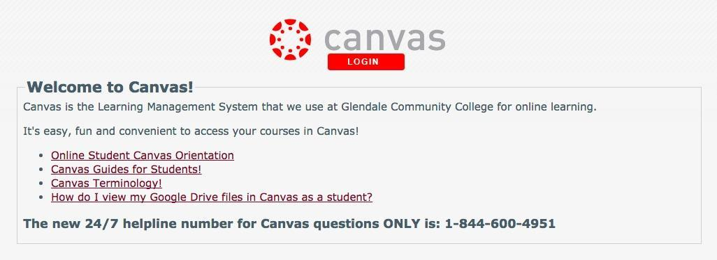

DE Management, Support, and Budget

The DE program requires current and stable infrastructure, which is reliant upon funding allocation and assignment of sufficient personnel to manage the DE program and technological upgrades and changes. An independent budget unit designation is necessary for the Distance Education Program at GCC to guarantee program quality. Full independent budget unit designation would afford the DE program permanent funding, as opposed to the blend of line item and one-time funding upon which much of the program currently relies.

- In fall of 2018, the second Full Program Review will need to be submitted for Distance Education. As stated in the 2015-2016 Full Program Review, the DE program at GCC is still understaffed to meet the high demands of this program. An accessibility specialist or robust software (such as Ally by Blackboard) to help faculty comply with federal online ADA/508 requirements is requested. Also, imperative to the advancement of the DE program, an Instructional Designer is needed to further aid in the development and creation of quality online courses. In order to enter the CVC-OEI and compete with the creation of the fully online community college (#115), GCC must provide an instructional designer to work with faculty to increase the quality of their online/hybrid courses in the area of regular and substantive integration, ADA/508 compliance and pedagogically sound course design from known effective practices in alignment with the CVC-OEI Course Design Rubric.

The technical personnel in the Information Technology Systems (ITS) department are responsible for maintaining the LMS, providing stable access, continually monitoring all technical systems related to online program delivery, and supporting faculty and staff with technical aspects of the LMS.

Currently, one classified employee provides additional technical/application support for all GCC faculty in the use of Canvas, along with the 24/7 Help Access line. The Welcome Center on the GCC main campus and 24/7 Help Access line assist all GCC students in the use and technical support of Canvas. Canvas training is also offered to all college employees. Workshops, webinars, open labs, and one-on-one training are offered through the Instructional Support Specialist.

All instructional, course design and pedagogical support are provided to faculty by the DE Faculty Development Coordinator (faculty release-time position) in the form of workshops, webinars, the Community of Practice, custom training, one-on-one assistance, and weekly instructional design office hours. The DE Faculty Development Coordinator also coordinates and oversees the Glendale Annual DE Recertification hours that all DE certified faculty at GCC must complete annually in order to stay DE instruction eligible. The requirement is 6-hours annually for full-time faculty and 3-hours annually for part-time faculty.

All DE policy, procedure, administration work (program review, single point of contact, institutional reporting), mentorship program, running the Committee on Distance Education (CoDE) and facilitation of the in-house, free, @ONE adopted Introduction to Online Teaching and Learning (IOTL) 40-hour, 4-week initial training for DE Certification is provided by the @ONE Faculty Trainer (faculty release-time position).

The mission of the Committee on Distance on Education (CoDE) is to cultivate policies and promote practices that contribute to the quality and growth of distance education at Glendale Community College.

In support of the institution’s Mission and Vision, the Glendale Community College’s Committee on Distance Education (CoDE) will work with the Distance Education Coordinator, Distance Education Faculty Development Coordinator, Academic Senate, and Division Chairs as instructional program leaders to facilitate and improve online teaching, learning, and technology.

With the understanding that faculty should have the primary responsibility for developing policies and promoting distance education practices, CoDE will support a learner-centered program designed to further student success by making recommendations to the Academic Senate. Each CoDE member will represent his/her division and act as a resource to all faculty members within their division regarding exploration, development, and implementation of strong pedagogical online strategies in the distance education environment.

The Committee on Distance Education (CoDE), chaired by the DE Coordinator, is a Senate committee and operates under Senate authority. In this context specifically, the DE Coordinator also has a reporting responsibility to the Senate and is supervised under the Dean of Library and Learning Support Services.

GCC Distance Education Alignment with the CVC-OEI

The Online Education Initiative (OEI) has merged with the California Virtual Campus (CVC) to now create the CVC-OEI

The Online Education Initiative (OEI) is a collaborative effort sponsored by the Chancellor’s Office among California Community Colleges (CCCs) to ensure that significantly more students are able to complete their educational goals by increasing both access to and success in high-quality online courses.

“Launched in Spring 2017 at five pilot colleges, the Course Exchange component of the Online Education Initiative provides a seamless pathway for students to register for online courses across participating colleges without requiring students to complete separate matriculation processes. Through the Course Exchange, students who cannot get the courses they need at their home college are able to enroll in equivalent online courses from another college (teaching college) that has available seats. Students enroll via a streamlined registration process at their home college”.

GCC to announce the acceptance into the CVC-OEI Consortium

The Online Education Initiative (OEI) is a collaborative effort sponsored by the Chancellor’s Office among California Community Colleges (CCCs) to ensure that significantly more students are able to complete their educational goals by increasing both access to and success in high-quality online courses.

In preparation for acceptance into the CVC-OEI, the Committee on Distance Education (CoDE) and the Academic Senate approved the use of the CVC-OEI Course Design Rubric as our DE course-measuring tool for CVC-OEI Courses, and an abridged version (consisting of highlighted areas that pertain to Title 5 Regulations and ADA/508 Laws) of the CVC-OEI Course Design Rubric as our measuring tool for all DE course baseline Compliance Checks.

The CVC-OEI Course Design Rubric contains the online course design standards developed and adopted by the OEI. The Rubric is intended to establish standards relating to course design, interaction and collaboration, assessment, learner support, and accessibility in order to ensure the provision of a high-quality learning environment that promotes student success and conforms to existing regulations.

In the development of these standards, the CVC-OEI team had access to significant work already undertaken in this area by @ONE, the CCC Distance Education Coordinator’s group, the Academic Senate for California Community Colleges (ASCCC), and the CCC Chancellor’s Office (CCCCO) along with a variety of other local college and nationally established standards.

A key component of the CVC-OEI exchange is course quality. A team of trained Peer Reviewers within the Design Academy rigorously reviews each course, and the instructor is provided assistance in instructional/course design and accessibility to get his or her course “Exchange ready.” This process is aimed at improving not just access, but also student success. GCC intends to work with instructors, starting in fall 2018, to create “Exchange ready” courses and participate in the CVC-OEI Design Academy.

The CVC-OEI Rubric is accompanied by an Online Course Design Guide:

An interesting read on CVC-OEI Facts: Illuminating Facts and Debunking Myths

GCC Distance Education Regulations at a Glance!

Distance Education: California Community College Curriculum - Title 5

The Accreditation Commission for Community and Junior Colleges (ACCJC)

American Disabilities Act (ADA) and Section 508 Compliance: Federal Law

GCC Distance Education Regulations and Accreditation

California Community College Curriculum - Title 5
(Please note that Title 5 language is due to change by fall of 2018)

§ 55200. Definition and Application
Distance education means instruction in which the instructor and student are separated by distance and interact through the assistance of communication technology. All distance education is subject to the general requirements of this chapter as well as the specific requirements of this article. In addition, instruction provided as distance education is subject to the requirements that may be imposed by the Americans with Disabilities Act (42 U.S.C. § 12100 et seq.) and section 508 of the Rehabilitation Act of 1973, as amended (29 U.S.C. § 794d).

§ 55202. Course Quality Standards
The same standards of course quality shall be applied to any portion of a course conducted through distance education as are applied to traditional classroom courses, in regard to the course quality judgment made pursuant to the requirements of section 55002, and in regard to any local course quality determination or review process. Determinations and judgments about the quality of distance education under the course quality standards shall be made with the full involvement of faculty in accordance with the provisions of subchapter 2 (commencing with section 53200) of chapter 2.

§ 55204. Instructor Contact
In addition to the requirements of section 55002 and any locally established requirements applicable to all courses, district governing boards shall ensure that:
(a) Any portion of a course conducted through distance education includes regular effective contact between instructor and students, through group or individual meetings, orientation and review sessions, supplemental seminar or study sessions, field trips, library workshops, telephone contact, correspondence, voice mail, e-mail, or other activities. Regular effective contact is an academic and professional matter pursuant to sections 53200 et seq.
(b) Any portion of a course provided through distance education is conducted consistent with guidelines issued by the Chancellor pursuant to Section 409 of the Procedures and Standing Orders of the Board of Governors.

§ 55206. Separate Course Approval
If any portion of the instruction in a proposed or existing course or course section is designed to be provided through distance education in lieu of face-to-face interaction between instructor and student, the course shall be separately reviewed and approved according to the district's adopted course approval procedures.

§ 55208. Faculty Selection and Workload.
(a) Instructors of course sections delivered via distance education technology shall be selected by the same procedures used to determine all instructional assignments. Instructors shall possess the minimum qualifications for the discipline into which the course's subject matter most appropriately falls, in accordance with article 2 (commencing with section 53410) of subchapter 4 of chapter 4, and with the list of discipline definitions and requirements adopted by the Board of Governors to implement that article, as such list may be amended from time to time.
(b) The number of students assigned to any one-course section offered by distance education shall be determined by and be consistent with other district procedures related to faculty assignment. Procedures for determining the number of students assigned to a course section offered in whole or in part by distance education may include a review by the curriculum committee established pursuant to section 55002(a)(1).
(c) Nothing in this section shall be construed to impinge upon or detract from any negotiations or negotiated agreements between exclusive representatives and district governing boards.

§ 55210. Ongoing Responsibility of Districts
If a district offers one or more courses or course sections in which instruction is provided through distance education for at least 51 percent of the hours of instruction in the course or course section, the district shall:
(a) maintain records and report data through the Chancellor's Office Management Information System on the number of students and faculty participating in new courses or sections of established courses offered through distance education ;
(b) provide to the local governing board, no later than August 31st of each year, a report on all distance education activity;
(c) provide other information consistent with reporting guidelines developed by the Chancellor pursuant to Section 409 of the Procedures and Standing Orders of the Board of Governors.

Federal Regulation Code 34 (CFR) §602.3

Distance education means education that uses one or more of the technologies listed in paragraphs (1) through (4) to deliver instruction to students who are separated from the instructor and to support regular and substantive interaction between the students and the instructor, either synchronously or asynchronously.

The technologies may include-- (1) The internet; (2) One-way and two-way transmissions through open broadcast, closed circuit, cable, microwave, broadband lines, fiber optics, satellite, or wireless communications devices; (3) Audioconferencing; or (4) Video cassettes, DVDs, and CD-ROMs, if the cassettes, DVDs, or CD-ROMs are used in a course in conjunction with any of the technologies listed in paragraphs (1) through (3).

Correspondence education means: (1) Education provided through one or more courses by an institution under which the institution provides instructional materials, by mail or electronic transmission, including examinations on the materials, to students who are separated from the instructor. (2) Interaction between the instructor and the student is limited, is not regular and substantive, and is primarily initiated by the student. (3) Correspondence courses are typically self-paced. (4) Correspondence education is not distance education.

The Accrediting Commission for Community and Junior Colleges (ACCJC)

Distance education is defined, for the purpose of accreditation review as a formal interaction which uses one or more technologies to deliver instruction to students who are separated from the instructor and which supports regular and substantive interaction between the students and instructor, either synchronously or asynchronously. Distance education often incorporates technologies such as the internet; one-way and two-way transmissions through open broadcast, closed circuit, cable, microwave, broadband lines, fiber optics, satellite, or wireless communications devices; audio conferencing; or video cassettes, DVDs, and CDROMs, in conjunction with any of the other technologies (ACCJC, 2017).

ACCJC Accreditation Requirements

The Accreditation Commission for Community and Junior Colleges (ACCJC) determines the accredited status of an institution. Part of the evaluation process includes an evaluation of a college’s distance education program and courses. More than a third of the ACCJC’s Guide to Evaluating and Improving Institutions (May 2017) accreditation standards include requirements for distance education (Accreditation Reference Handbook, July 2016).

ACCJC Requirements for Online/Hybrid Instructors

Many of the distance education requirements are the responsibility of the institution and are beyond the responsibility of an individual instructor, but there are requirements that are instructor-specific:

- Online/hybrid instructors are to maintain regular and effective contact in online/hybrid courses;

- All instructors assess SLOs and discuss the results with colleagues to identify improvements to courses;

- All classes follow the Course Outline of Record (COR). The means of instruction varies between online and face-to-face, but the Methods of Instruction, Outside Class Assignments and Methods of Evaluation are the same;

- Federal ADA/508 Law requires that we serve all students. An instructor can help make students aware of the many services available to them online;

- Distance education instructors are expected to follow good teaching practices, including those identified by our accrediting commission.

DE Class Size Caps – According to the AFT:

Article 40 of the American Federation of Teachers (AFT) Contract states, “[Distance Learning] DL class size shall be consistent with Article 12. DL class size shall not exceed 40. Class size limits shall only be raised with the prior approval of the assigned faculty member in consultation with the department/division chair and the appropriate vice president or designee. Beginning at the point a class reaches its enrollment limits, students may only be added with the permission of the course’s assigned faculty member.”

For any concerns about course enrollment, please contact your division or department chair.

American Disabilities Act (ADA) and Section 508 Compliance

The Department of Justice (DOJ) published the Americans with Disabilities Act (ADA) Standards for Accessible Design in September 2010. These standards state that all electronic and information technology must be accessible to people with disabilities.

The ADA differs from Section 508 regulations, which are an amendment to the Rehabilitation Act of 1973 and apply to all information technology, including computer hardware, software, and documentation.

The ADA standards apply to commercial and public entities that have “places of public accommodation” which includes the Internet Interactive Accessibility.

GCC Distance Education Definitions and Ticket Notes

Distance Education Course Definitions

Online Courses: An Online course is offered 100% online. Students cannot be required to meet face-to-face for office hours, orientations, homework, exams, distribution of resource materials, or any other course component. An online course shall utilize features of the Learning Management System (LMS), Canvas, such as Course Documents, Discussion Boards, Virtual Classrooms, Groups, Assignments, External Links, Digital Drop Boxes and Grade Books, Asynchronous and/or Synchronous learning, etc. All course instructions, materials, assignments, and discussions are posted and completed online. Online courses require for both the student and instructor the same amount of coursework and hours outside of the classroom as traditional courses. Online courses are noted as such in the schedule of classes.

Hybrid Courses: A Hybrid course is offered 1%-99% online with online content and/or activities. Teaching is a combination of face-to-face meetings and online activities. A Hybrid course can utilize features of the Learning Management System (LMS), Canvas, such as Course Documents, Discussion Boards, Virtual Classrooms, Groups, Assignments, External Links, Digital Drop Boxes and Grade Books, Asynchronous and/or Synchronous learning, etc. The course can be offered during regularly scheduled class times or with online components that replace some of the regularly scheduled class meetings. The instructor will give face-to-face orientation and in-class exams as stated in his or her syllabus. Hybrid courses are noted as such in the schedule of classes.

Note: Hybrid means that any portion of instructional contact hours stipulated in the Course Outline on Record (COR) in a proposed or existing course that is designed to be provided through distance education in lieu of face-to-face interaction between instructor and student is considered a distance education course and is subject to state regulations, federal laws, local district guidelines, and must be separately reviewed and approved according to the district's adopted course approval procedures.

Proctored Online Courses: Assignments and examinations in a Proctored Online Course will be submitted in an asynchronous manner, but you will be required to take tests at a proctoring facility. Your instructor will provide proctoring accommodations at GCC. Off-site proctoring services could be available at the discretion of the instructor.

In addition to assigning DE certified faculty to online/hybrid course sections, it is also necessary to use a standardized ticket note to describe online or hybrid courses sections to students when registering.

Standardized Ticket Notes
• Demonstrate GCC’s compliance with Federal Law, State Regulations, and ACCJC guidelines for online instruction;

• Establish a comprehensive college-wide protocol for logging in to all distance education course sections;
• Make it easier for students to understand what is required of them to log-in and complete their initial course Check-In Assignment.

Title 5 Considerations and Ticket Notes

A letter sent in October 2011 by the Department of Education calls upon postsecondary distance education programs to put more stringent measures into place to make certain that students are not just enrolled in courses, but also actively participate:

“...institutions [need] to take steps necessary to ensure that students are academically engaged prior to disbursing Title IV student aid funds. If students do not begin attendance, Title IV funds must be returned” (34 CFR 668.21(a))(Runcie & Ocha).

Recent Federal law and ACCJC guidelines to prevent financial aid fraud mean that initial student logins to distance education courses no longer count as student participation. Several online programs in the community college system have recently been targeted by financial aid fraud schemes in which a ‘student’ registers for an online course, logs in, and then drops the course after financial aid funds have been dispersed.
PLEASE NOTE: It is imperative that instructor's drop all non-participating DE Students by GCC's Census Date. To confirm participation/attendance, best practices require that DE courses have a Course Check-In Assignment with a firm due date during the first week of instruction.

CoDE Approved Standardized Ticket Notes:

NOTE: HYBRID CLASS— For information on what is required of you when taking an online course visit: http://glendale.edu/online. (For example: Face-to-face classes will convene on x from x to x. Real-time (synchronous) learning is required on x from x to x). Students must review the instructor generated Welcome Letter via GCC email and complete the Course Check-In Assignment described in the Welcome Letter by Sunday at 11:59pm not to be dropped from the course. Students should possess basic computer skills and have access to the Internet, either from home or from the computer labs on-campus. This course requires reading, writing, engaging in frequent online activities, and weekly assignment deadlines. Instructor: xxx; xxx@glendale.edu

NOTE: ONLINE CLASS— For information on what is required of you when taking an online course visit: http://glendale.edu/online. No face-to-face time is required for this fully online class. (For example: Real-time (synchronous) learning is required on x from x to x). Students must review the instructor generated Welcome Letter via GCC email and complete the Course Check-In Assignment described in the Welcome Letter by Sunday at 11:59pm to not be dropped from the course. Students should possess basic computer skills and have access to the Internet, either from home or from the computer labs on-campus. This course requires reading, writing, engaging in frequent online activities, and weekly assignment deadlines. Instructor: xxx; xxx@glendale.edu

NOTE: PROCTORED ONLINE CLASS— For information on what is required of you when taking an online course visit: http://glendale.edu/online. Students must review the instructor generated Welcome Letter via GCC email and complete the Course Check-In Assignment described in the Welcome Letter by Sunday at 11:59pm to not be dropped from the course. Students should possess basic computer skills and have access to the Internet, either from home or from the computer labs on-campus. This course requires reading, writing, engaging in frequent online activities, and weekly assignment deadlines. Instructor: xxx; xxx@glendale.edu

Note: Bolded text should be customized with specific class information.

Thank You to the DE Strategic Plan Task Force!

Thank you to the Distance Education DE Strategic Plan Task Force, the Committee on Distance Education, and the Academic Senate for their input, time, and energy that went toward creating this DE 5-Year Strategic Plan.

The mission of the Committee on Distance on Education (CoDE) is to cultivate policies and promote practices that contribute to the quality and growth of distance education at Glendale Community College.

In support of the institution’s Mission and Vision, the Glendale Community College’s Committee on Distance Education (CoDE) will work with the Distance Education Coordinator, Distance Education Faculty Development Coordinator, Academic Senate, and Division Chairs as instructional program leaders to facilitate and improve online teaching, learning, and technology.

With the understanding that faculty should have the primary responsibility for developing policies and promoting distance education practices, CoDE will support a learner-centered program designed to further student success by making recommendations to the Academic Senate. Each CoDE member will represent his/her division and act as a resource to all faculty members within their division regarding exploration, development, and implementation of strong pedagogical online strategies in the distance education environment.

Please see the Committee on Distance Education (CoDE) website for more information on the DE team at GCC and CoDE Agenda and Minutes

The Distance Education 5-Year Strategic Plan

Distance Education Statistic Report from Fall 2011-Spring 2018

CCC Chancellor’s Office: 2017 Distance Education Report

The GCC Institutional Master Plan 2018-2025 and Master Plan Goals

D.5 Ensure Student Learning: Increase effectiveness of distance education, including improving student access to it and the support of faculty in content creation, online pedagogy, alignment with statewide online education standards, and instructional design.EA-1, EA-5 Vice President, Instructional Services; ongoing (GCC IMP, 20).

