

Glendale Community College
Distance Education Handbook

2019-2020

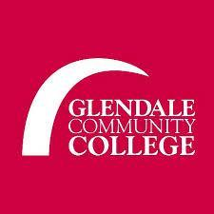

Table of Contents
Table of Contents 2
Introduction and Purpose of Distance Education at GCC 4
- Distance Education Program Mission Statement 4
- Distance Education Vision and Core Values Statement 4
Distance Education Student and Faculty Website 6
DE 5-Year Plan, Statistics, CCCC DE Report 7
DE Handbook, Newsletters, and DE Certified Fact-Sheet 8
DE Policies and Procedures 9
• Distance Education Course Requirements 9
• Regular and Effective Contact Quick Guide 9
• Student Rights in an Online and Hybrid Course 9
DE Certifications through GCC 10
• Alternative Ways of Becoming Distance Education Certified at GCC 10
Participating in the CVC-OEI through GCC 11
DE Recertification and Faculty Mentorship Program 12
DE Ticket Notes, Course Definitions, Course Approval 13
Distance Education Course Requirements 14
Instructional, ADA/508, Faculty Resources, and Canvas 15
DE Laws, Guidelines, Accreditation, Faculty Evaluation 16
CoDE, Academic Senate, Guild, DE Team 17
• Thank You to the DE Handbook Team! 17

Introduction and Purpose of Distance Education at GCC

Distance Education Program Mission Statement

The Glendale Community College Distance Education Program Mission is to serve a diverse population of students by providing the opportunities and support to achieve their educational and career goals. The Distance Education Program is dedicated to the importance of higher education in the evolving urban environment of Glendale and the Greater Los Angeles area and beyond. Faculty and staff engage students in rigorous and innovative online learning experiences that enhance and sustain the cultural, intellectual, and economic vitality of the community. As part of its mission, Glendale Community College and the Distance Education Program are committed to student success by promoting:
- transfer preparation, certificates, associate degrees, career development, technical training, continuing education, and basic skills instruction;
- communication, critical thinking, information competency, quantitative reasoning, global awareness, personal responsibility, and application of knowledge;
- collaboration among disciplines and openness to the diversity of the human experience;
- student services, learning support, and technology that enable students to reach their educational goals in an efficient and timely manner;
- universally accessible, academically sound pedagogical strategies, and technologically advanced instruction at a distance, while responding to community needs and promoting faculty innovation;
- student retention by ensuring uniformity in terms of Learning Management System (LMS) and online instructor responsibility and accountability;
- clear expectations, guidelines and policies for instructors teaching distance education courses in order to adhere to the requirements of Title 5 Regulations, Federal ADA/Section 508 Laws, the American Federation of Teachers (AFT) Contract (Article 40), and the Accrediting Commission for Community and Junior Colleges (ACCJC) of the Western Association of Schools and Colleges (WASC) which oversees accreditation at Glendale Community College.

Distance Education Vision and Core Values Statement

The Glendale Community College Distance Education Program seeks to lead in educational excellence, innovation, training, delivery and support of online and hybrid instructional modalities. Glendale Community College looks to participate in the Online Education Initiative (OEI) in order to provide our students, and those throughout California, with high quality online courses.

The DE Program at GCC is guided by the following Core Values:

- Leadership in technology, instructional innovation, and cultivation of lifelong learning and professional development;
- Dedication to best practices in distance education and support services for student success;
- Commitment to communication and collaboration among key stakeholders;
- Transparency in the decision-making process, while maintaining integrity and professionalism.

Welcome to Distance Education (DE) at Glendale Community College (GCC)!

GCC offers access to higher education and learning opportunities via distance education. Distance education means instruction in which the instructor and student are separated by distance and interact through the assistance of communication technology. DE courses are ideal for independent, self-directed, and motivated students who have access to broadband Internet on an ongoing basis.

The goals of this handbook are broken into six categories:

- Articulate the mission and goals of Distance Education at the College
- Inform faculty about the approved policies and procedures related to distance education courses;
- Provide technical and pedagogical support and resources for faculty teaching online and hybrid courses;
- Furnish information about training and mentoring for online and hybrid course delivery methods;
- Define best practices in distance education and how those are incorporated into course design and delivery;
- Offer comprehensive resources for ongoing faculty development, including training for initial certification as well as recertification for DE instruction-eligibility.

This handbook serves as an introduction to the distance education world, detailing the requirements and best practices of a distance education course.

Distance Education Student and Faculty Website

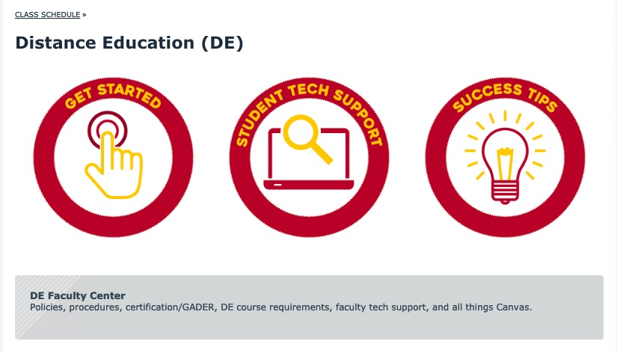

The goal of the Distance Education (DE) website is to be a one-stop-shop for all DE Student and Faculty questions, needs, and ideas. The main homepage is student-centric so that the three big buttons are designed to answer students’ pressing questions and offer Canvas tech support. At the bottom of the homepage are links for faculty access, which lead to the DE Faculty Center website.

The DE Faculty Center page comprises five major categories:

- DE Certification at GCC with a registration form to attend the in-house certification course, taught by an @ONE Trainer.
- Canvas Sample Course Shell, which is a shell for GCC faculty to explore, tinker with, adapt and adopt, if interested.
- GADER (Glendale Annual Distance Education Recertification) which has information about GADER opportunities, as well as what type of coursework or workshops count as GADER.
- CVC-OEI Finish Faster to explain how GCC is involved and how faculty can participate and become a part of the exchange.
- 3-2-1 Go! If you are just building your online course, and you are feeling overwhelmed, here are some helpful videos to walk you through every step of the process.

Also within the DE Faculty Center is the DE Polices & Procedures webpage, which houses most of the information found this DE Handbook.

DE 5-Year Plan, Statistics, CCCC DE Report

Distance Education Strategic 5-Year Plan

In conjunction with the Academic Senate and Guild, the Committee on Distance Education (CoDE) created and approved a GCC Distance Education Strategic 5-Year Plan 2018-2023.

The Distance Education Strategic 5-Year Plan can also be found under the DE Website > DE Faculty Center > DE Policies & Procedures webpage.

Distance Education Statistics Fall 2011-Spring 2018

GCC’s Office of Research and Planning Department created a spreadsheet of GCC Distance Education Statistics Fall 2011-Spring 2018 to aid in the creation of the Distance Education Strategic 5-Year Plan.

The Distance Education Statistics can also be found under the DE Website > DE Faculty Center > DE Policies & Procedures webpage.

CCC Chancellor’s Office: 2017 Distance Education Report

The California Community Colleges Chancellor’s Office released a 2017 Distance Education Report focusing on 2006-2016 DE trends in California Community Colleges.

The CCC 2017 DE Report can also be found under the DE Website > DE Faculty Center > DE Policies & Procedures webpage.

DE Handbook, Newsletters, and DE Certified Fact-Sheet

Distance Education Handbook: 2019-2020

The most current DE Handbook (GCC Distance Education Handbook 2018-2019) can also be found under the DE Website > DE Faculty Center > DE Policies & Procedures webpage.

Distance Education Monthly Newsletters

The DE Team at GCC produces a Distance Education Monthly Newsletter during the spring and fall terms. These Newsletters are housed under the DE Website > DE Faculty Center > DE Policies & Procedures webpage.

Distance Education Fact-Sheet for Newly Certified Faculty

If you are a newly DE Certified Faculty member at GCC, please download the Distance Education Fact-Sheet for Newly DE Certified Faculty! or find this Fact-Sheet under the DE Website > DE Faculty Center > DE Course Requirements webpage.

DE Policies and Procedures

Distance Education Course Requirements

Title 5 §55202. Course Quality Standards - The same standards of course quality shall be applied to any portion of a class conducted through distance education as are applied to in-person classes...”

For more information and clarification on Mandatory DE Requirements, visit the Distance Education Course Requirement webpage.

If you are a newly DE Certified Faculty member at GCC, please download the Distance Education Fact-Sheet for Newly DE Certified Faculty! or find this Fact-Sheet under the DE Website > DE Faculty Center > DE Course Requirements webpage.

Regular and Effective Contact Quick Guide

Title 5 §55204. Instructor Contact:
In addition to the requirements of section 55002 and any locally established requirements applicable to all courses, district governing boards shall ensure that:
(a) Any portion of a course conducted through distance education includes regular effective contact between instructor and students, and among students, either synchronously or asynchronously, through group or individual meetings, orientation and review sessions, supplemental seminar or study sessions, field trips, library workshops, telephone contact, voice mail, e-mail, or other activities. Regular effective contact is an academic and professional matter pursuant to sections 53200 et seq.
(b) Any portion of a course provided through distance education is conducted consistent with guidelines issued by the Chancellor pursuant to section 409 of the Procedures and Standing Orders of the Board of Governors.”

For more information on regular and effective contact in a DE course and the Quick Guide to including this contact, visit the Regular and Effective Contact Quick Guide webpage.

Student Rights in an Online and Hybrid Course

DE students at GCC have the right to a quality online or hybrid course, and the right to have regular and effective contact with their instructor and fellow classmates.

For more information on these student rights, visit the Student Rights in Online and Hybrid Course webpage.

DE Certifications through GCC
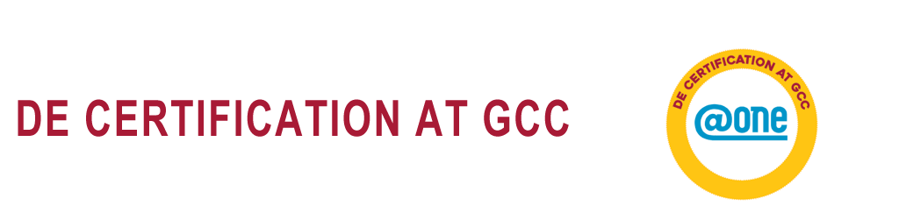

To be eligible to teach fully online and/or hybrid courses at GCC, instructors are required to be both DE Certified and DE Instruction Eligible.

DE Certification means that the instructor is not only competent in using the institution’s chosen learning management system (LMS), but also understands online pedagogy and effective course design.

Visit the DE Certification at GCC for further details and registration options.

Alternative Ways of Becoming Distance Education Certified at GCC

According to the Committee on Distance Education (CoDE) and approved by the Academic Senate, instructors may become DE Certified through Equivalency in two ways: Through coursework, or by performance.

Visit the Alternative Ways to Become DE Certified website for further details.

If you are a newly DE Certified Faculty member at GCC, please download the Distance Education Fact-Sheet for Newly DE Certified Faculty! or find this Fact-Sheet under the DE Website > DE Faculty Center > DE Course Requirements webpage.

Participating in the CVC-OEI through GCC

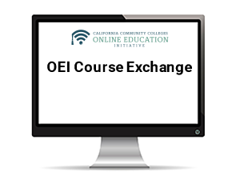
The Online Education Initiative (OEI) is a collaborative effort sponsored by the Chancellor’s Office among California Community Colleges (CCCs) to ensure that significantly more students are able to complete their educational goals by increasing both access to and success in high-quality online courses.
The OEI has merged with the California Virtual Campus (CVC) to now create the OEI-CVC: http://cvc.edu/
To find out more the OEI, CVC and GCC involvement, visit the GCC’s Finish Faster Online website.

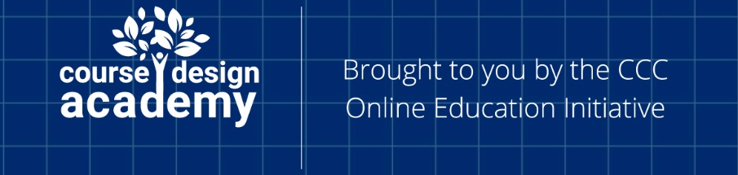
If you would like to join the Design Academy so your DE course is eligible to run in the OEI but are concerned about not having the time to finish the course, visit this website to learn about a unique Opportunity to Earn Release Time or Stipend to Complete the Design Academy with GCC’s support.

Note: In preparation for acceptance into the Online Education Initiative (OEI), the Committee on Distance Education (CoDE) and the Academic Senate approved the use of the OEI Rubric as our course-measuring tool for DE excellence, and an abridged version as our measuring tool for all GCC DE course baseline compliance checks.
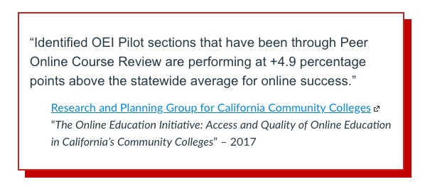

DE Recertification and Faculty Mentorship Program

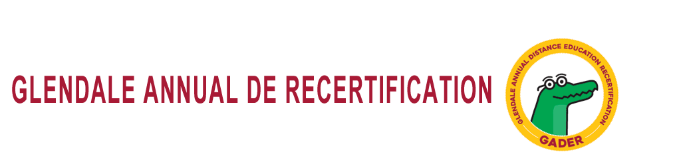

Annual GADER (Glendale Annual Distance Education Re-certification) is required before faculty names will be forwarded to the District by the DE Coordinator for scheduling to teach online or hybrid courses.
For further details on GADER, as well as a list of the types of activities that are already approved for GADER, please see the GADER policies and procedures page.
If you plan your own GADER, please use this individually planned activity GADER form to provide rationale for why the activity should qualify as GADER, as well as reflection on your learning from the activity.
For more information on GADER, visit the DE Annual Recertification website.

Distance Education Faculty Mentorship Program

The goal of the DE faculty mentorship program at GCC is to develop and maintain a robust DE faculty support system to assist all DE certified instructors in navigating the course design, development, revision, best practices, and course facilitation processes.

For more information on the evolution and of this program and how to become involved, visit the Distance Education Faculty Mentorship Program webpage.

DE Ticket Notes, Course Definitions, Course Approval

Distance Education Standardized Ticket Notes

In addition to assigning DE certified faculty to online/hybrid course sections, it is also necessary to use a standardized ticket note to describe online or hybrid courses.

For an explanation on why Ticket Notes are necessary and sample DE Ticket Notes, visit the Distance Education Standardized Ticket Notes webpage.

Distance Education Course Definitions

Glendale Community College has three Distance Education Course Definitions that were approved by Committee on Distance Education (CoDE).

New Distance Education Courses: Approval Process

Title 5 §55206. Separate Course Approval – “If any portion of the instruction in a new or existing course or course section is designed to be provided through distance education, an addendum to the official course outline of record shall be required.”

The Committee on Distance Education (CoDE) and the Curriculum and Instruction Committee (C&I) have developed a process (approved by the Academic Senate) for DE course approval.

For more information on this DE course approval process, visit the DE Course Proposal: DE Addendum webpage.

Distance Education Course Requirements

Distance Education Course Requirements

There are currently Six Mandatory DE Requirements that must be in a GCC Distance Education (DE) course by way of the Welcome Letter, Syllabus, Policy Page, or Modules in Canvas.

- Hybrid/Online Welcome Letter A Distance Education instructor must create and send a Welcome Letter 2-5 days before the semester begins to students via Canvas email and PeopleSoft. The Welcome Letter must inform students to complete the described course Check-In Assignment by the end of week 1 to avoid being dropped from the course. Sample Welcome Letter for Review

- Hybrid/Online Check-In Assignment
The course Check-In Assignment is a MANDATORY requirement for all distance education classes. If a student does not complete the course Check-In Assignment within 1 week from when the course begins, the instructor may drop him/her from the class.

- DE Instructional Practice/Synchronous Office Hours
Motion 2018-07: The Senate vigorously promotes the use of pedagogical methods and tools that have been recognized as Best Practices in the instruction of Distance Education classes, and acknowledges instructors' rights to select from recognized or emerging pedagogies and tools, synchronous or asynchronous, in their instructional practice.

GCC Collective Bargaining Agreement (July 1, 2015 - June 30, 2018) Section 3. Office Hours A. “For online office hours, instructors shall communicate with their students synchronously. It is recommended that the faculty member send a notification to their students at the beginning and end of each office hour period held online...Instructors should offer office hours in blocks no shorter than thirty (30) minutes each.”

- Regular and Effective Contact/Quick Guide
When designing a DE course, keep the following suggestions in mind to establish Regular, Effective and Authentic Contact.

- Online Distance Education Drop Policies
The course Check-In Assignment is a requirement mandated by the Department of Education (Reg. 66952) for all distance education classes. If a student does not complete the course Check-In Assignment within 1 week from when the course begins, the instructor may drop him/her from the class.

- Federal ADA/508 Compliance Policies
It is not always easy, but staying ADA/508 compliant is a federal law.

Instructional, ADA/508, Faculty Resources, and Canvas

- DE Instructional Resources

Need inspiration? Here are some resources that can maintain and ensure a strong online learning environment. For more information on DE Instructional Resources, visit the DE Instructional Resources webpage.

- DE Accessibility Resources

Glendale Community College seeks to make all programs and services, including electronic and information technology accessible to people with disabilities. For more information on ADA/508 Course Requirements, Standards and Remediation Assistance, visit the DE Accessibility Resources webpage.

- DE Faculty Tech Support

Faculty seeking 24/7 Canvas Support, face-to-face assistance, getting started handouts, and instructor Canvas guides, visit the DE Faculty Tech Support webpage.

- All Things Canvas



Canvas is the chosen Learning Management System (LMS) at GCC for all faculty and students. All faculty and students can log into Canvas via the main GCC homepage.

The All Things Canvas webpage for faculty contains various resources on grading, media use, accessibility, LTI integrated Tools, printing, using Commons, internet/browser issues, and Dealing with Online Cheating/Plagiarism.

For more information on All Things Canvas, Canvas Resources, Plagiarism Detection and Suggestions for Derailing Online Cheating, visit the All Things Canvas webpage.

DE Laws, Guidelines, Accreditation, Faculty Evaluation

DE Laws Pertaining to Title 5, ACCJC, ADA/508 at a Glance

For the illustrations that will display the most important DE State and Federal Laws at a Glace, visit the California Title 5 Guidelines, The Accrediting Commission for Community and Junior Colleges, and Federal American Disabilities Act/Section 508 Compliance for Distance Education webpage.

DE Laws Explained Pertaining to Title 5, ACCJC, Code 34, AFT, HEOA 2008, DOE Reg. 66952, and ADA/508

For complete language regarding DE State and Federal laws, visit the California Title 5 Guidelines, The Accrediting Commission for Community and Junior Colleges, Federal Regulation Code 34, American Federation of Teachers, Higher Education Opportunity Act 2008, DOE Reg. 66952, and Federal American Disabilities Act/Section 508 Compliance for Distance Education webpage..

DE Faculty Evaluation Form and Process

TBA (To Be Created by CoDE/Senate/Guild Taskforce)

CoDE, Academic Senate, Guild, DE Team

Committee on Distance Education (CoDE)

The mission of the Committee of Distance on Education (CoDE) is to cultivate policies and promote practices that contribute to the quality and growth of distance education at Glendale Community College. The Committee on Distance Education (CoDE), which the DE Coordinator chairs, is a Senate committee and operates under Senate authority.

For more information on CoDE, its purpose and Agenda/Minutes, visit the Committee on Distance Education (CoDE) webpage.

Notable Academic Senate DE Approvals and the Guild Contract

CoDE makes recommendations to the Academic Senate and the Academic Senate approves or denies the recommendation. The recommendation might then need to be sent through more governance bodies to be fully recognized and enforced.

The GCC Collective Bargaining Agreement (July 1, 2015 - June 30, 2018) affects all GCC Faculty, including those who teach DE classes.

For more information on the Senate recommendations and approvals, visit the Notable Academic Senate DE Approvals and the Guild Contract webpage.

Meet Your GCC Distance Education Team

GCC has a passionate and skilled team of faculty and staff to assist you during your DE journey. Learn more about this team on the GCC Distance Education Team webpage.

--------------------------------------------

Thank You to the DE Handbook Team!

Thank you to the Distance Education Handbook Team, the Committee on Distance Education (CoDE), and the Academic Senate for their input, time, and energy in creating the DE Handbook: 2019-2020.

