Do you Do You Love DE? | 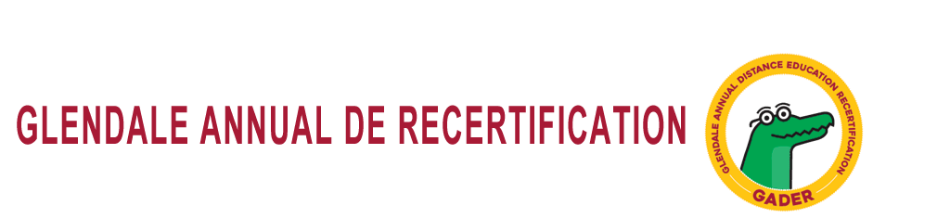  DE Community of Practice…How does it work?  The Distance Education Community of Practice (CoP) at GCC is organized within a Canvas course of the same name. All DE certified faculty have been added to the course. If you do not see the course or your dashboard, contact defacdev@glendale.edu to be added.  All Community of Practice (CoP) Modules have 3 Parts:  I. Read or Watch something in advance of meeting (in the Canvas course)  II. Discuss something in advance of meeting (in the Canvas course)  III. Meet face-to-face (in the Faculty Innovation Center, SV 105; participation by Zoom welcome)!  You will be awarded 3 hours of GADER for each Module.  If you cannot come to the meeting, you can still be awarded 2 hours of GADER; however, you cannot be awarded GADER for attending the face-to-face meeting without doing the online meeting work in advance.  This fall, lunch will be served at each face-to-face GADER meeting. Check the GADER page for all dates and times!  If you would like lunch, please be sure to participate in the online meetings and also RSVP a minimum of 72 hours in advance for free lunch.  https://tinyurl.com/GCC-GADER  -----------------------------------------------------------------  @ONE Professional Development for GADER  You may take a professional development course at @ONE.  These @ONE courses are high quality professional development, and you are strongly encouraged to consider taking one or more if you plan to continue teaching online.  http://onlinenetworkofeducators.org/pd/registration-introduction/  -----------------------------------------------------------------  Need Canvas Tech Support?  https://tinyurl.com/CanvasTechSupport
  Hi GCC Faculty! Are you a DE Superstar? Might you be interested in teaching one or more workshops as part of our best practices in online teaching series? If so, we need to talk! Please email defacdeve@glendale.edu with the following information:
  1. Name, division, contact information.
  2. How long you’ve been teaching online, how many classes you teach online, and what type (e.g. hybrid or fully online)?
  3. Is your course mostly OEI rubric and 508 aligned?
  4. Would you be interested in leading workshops or other types of training on one of these topics:
  • Do you make good use of pages?
  • Are you great at the Gradebook?
  • Do you know the basic four (or so) of accessibility compliance?
  • Do you have your online students doing collaborative projects?
  • Do you have an awesome homepage?
  • Are you innovative in how you use the discussion board?
  • Looking at the OEI rubric, are there sections that you feel like you’re nailing it?
    - DE Coordinator
  
  Alexa Schumacher, Ph.D
  de@glendale.edu
  818-240-1000, x5298
  Faculty Innovation Center (SV112)
  http://glendale.edu/online
Page 2

