Polynomial Function Graphing
Math 110A Lab – Student Worksheet

Name _____________________________

Directions: For each graph, write a function for the given graph in both factored and expanded form.
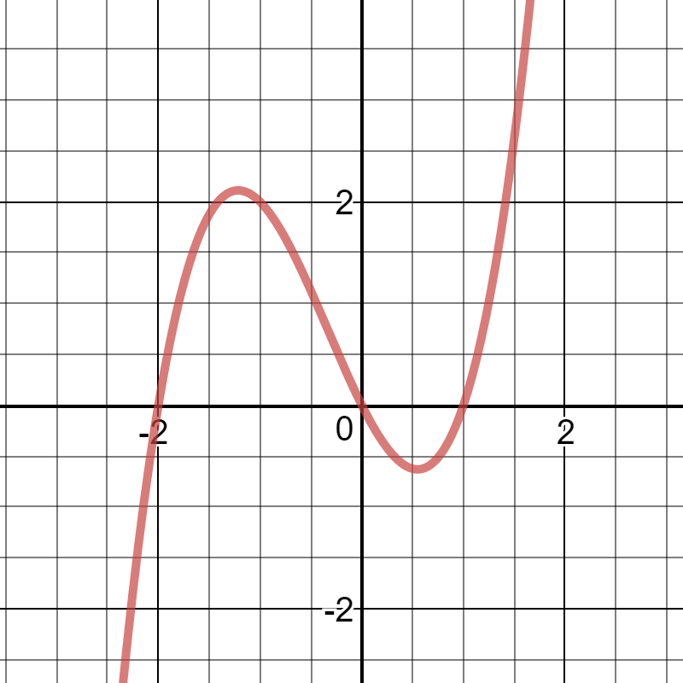
- Factored form: $f\left(x\right)=________________________________$
Expanded form: $f\left(x\right)=________________________________$

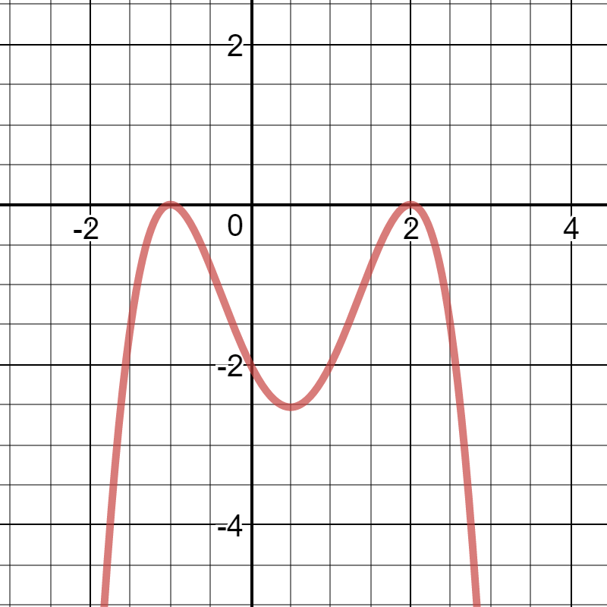
- Factored form: $f\left(x\right)=________________________________$
Expanded form: $f\left(x\right)=________________________________$

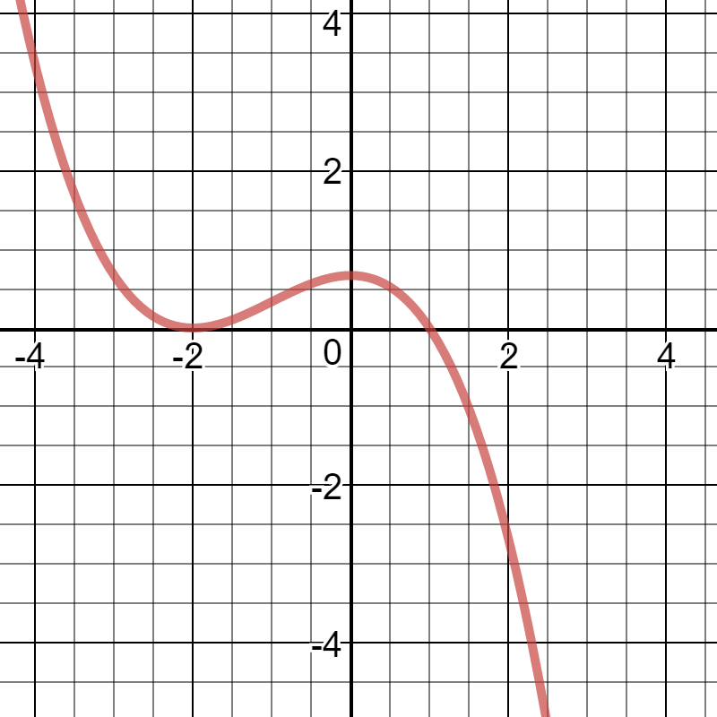
- Factored form: $f\left(x\right)=________________________________$
Expanded form: $f\left(x\right)=________________________________$

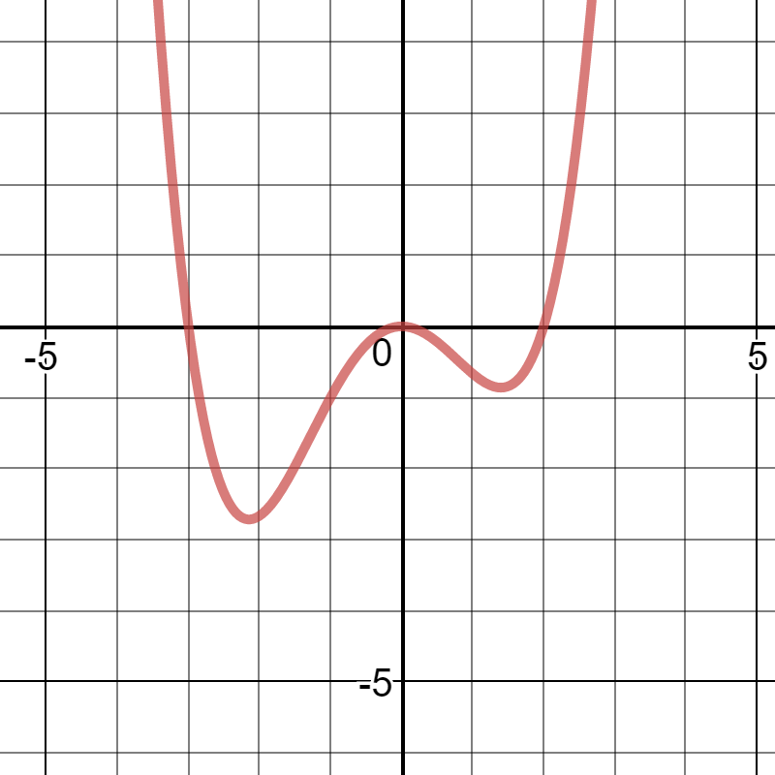
- Factored form: $f\left(x\right)=________________________________$
Expanded form: $f\left(x\right)=________________________________$

